Database Basics MS SQL Regular Exam – 05 Dec 2023
Exam problems for the "Database Basics" course @ SoftUni.
Submit your solutions in the SoftUni Judge system at Judge.

Railways Database

Section 1. DDL (30 pts)
You have been given the E/R Diagram of the RailwaysDb database.
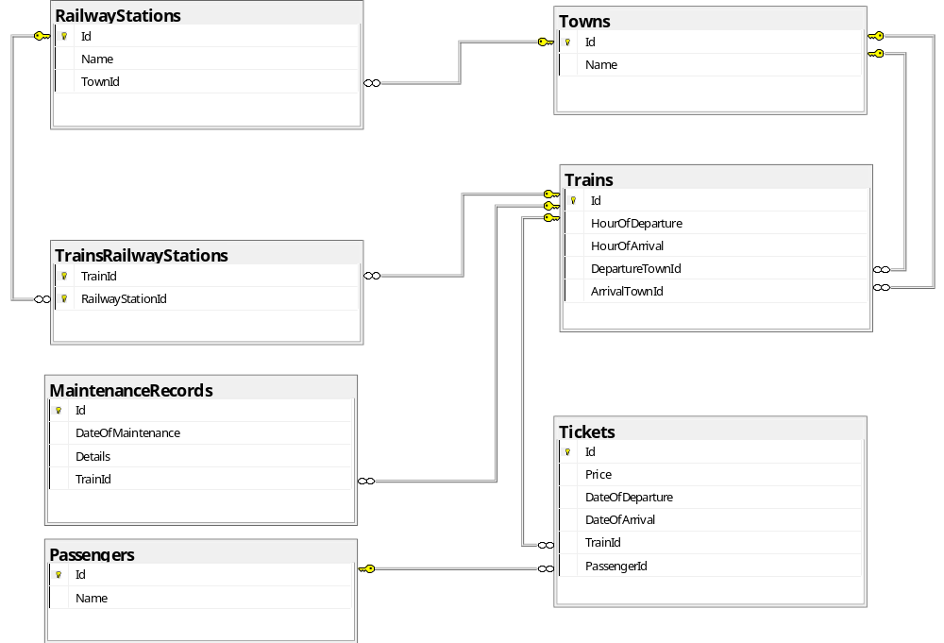
Create a database called RailwaysDb. You need to create 7 tables:
- Passengers – contains information about the names of the passengers;
- Towns – contains information about the names of the towns;
- RailwayStations – holds data about railway stations, such as their names and associated town IDs, indicating the towns where these stations are located.;
- Trains – details about trains, including departure and arrival times and their corresponding town IDs;
- TrainsRailwayStations - Manages the many-to-many relationship between trains and railway stations, indicating which trains stop at which stations;
- MaintenanceRecords – records maintenance activities for trains, including dates and detailed descriptions of maintenance work;
- Tickets – contains information about tickets, including price, departure and arrival date, and associated train and passenger IDs;
NOTE: Keep in mind that Judge doesn't accept "ALTER" statement and square brackets naming (when the names are not keywords).
NOTE: Please keep in mind that in case you have to work with a date, you have to use the exact same data type, described in the models tables. If you don't use the correct type, the Judge system won't accept your submission as correct.

You have been tasked to create the tables in the database by the following models:

Passengers
Column Name | Data Type | Constraints
Id | Integer from 0 to 2,147,483,647 | PK, Unique table identification, Identity
Name | String up to 80 symbols, Unicode | Null is not allowed

Towns
Column Name | Data Type | Constraints
Id | Integer from 0 to 2,147,483,647 | PK, Unique table identification, Identity
Name | String up to 30 symbols | Null is not allowed

RailwayStations
Column Name | Data Type | Constraints
Id | Integer from 0 to 2,147,483,647 | PK, Unique table identification, Identity
Name | String up to 50 symbols | Null is not allowed
TownId | Integer from 0 to 2,147,483,647 | Relationship with table Towns, Null is not allowed

Trains
Column Name | Data Type | Constraints
Id | Integer from 0 to 2,147,483,647 | PK, Unique table identification, Identity
HourOfDeparture | String up to 5 symbols | Null is not allowed
HourOfArrival | String up to 5 symbols | Null is not allowed
DepartureTownId | Integer from 0 to 2,147,483,647 | Relationship with table Towns, Null is not allowed
ArrivalTownId | Integer from 0 to 2,147,483,647 | Relationship with table Towns, Null is not allowed

TrainsRailwayStations
Column Name | Data Type | Constraints
TrainId | Integer from 0 to 2,147,483,647 | PK, Unique table identification, Relationship with table Trains, Null is not allowed
RailwayStationId | Integer from 0 to 2,147,483,647 | PK, Unique table identification, Relationship with table RailwayStations, Null is not allowed

MaintenanceRecords
Column Name | Data Type | Constraints
Id | Integer from 0 to 2,147,483,647 | PK, Unique table identification, Identity
DateOfMaintenance | Date | Null is not allowed
Details | String up to 2000 symbols | Null is not allowed
TrainId | Integer from 0 to 2,147,483,647 | Relationship with table Trains, Null is not allowed

Tickets
Column Name | Data Type | Constraints
Id | Integer from 0 to 2,147,483,647 | PK, Unique table identification, Identity
Price | Decimal number with two-digit precision | Null is not allowed
DateOfDeparture | Date | Null is not allowed
DateOfArrival | Date | Null is not allowed
TrainId | Integer from 0 to 2,147,483,647 | Relationship with table Trains, Null is not allowed
PassengerId | Integer from 0 to 2,147,483,647 | Relationship with table Passengers, Null is not allowed

Database design
Submit all of yours CREATE statements to Judge (only the creation of tables).

Section 2. DML (10 pts)
Before you start, you have to import "Dataset.sql ". If you have created the structure correctly, the data should be successfully inserted.
In this section, you have to do some data manipulations:

Insert
Let's insert some sample data into the database. Write a query to add the following records into the corresponding tables. All IDs (Primary Keys) should be auto-generated.

Trains
HourOfDeparture | HourOfArrival | DepartureTownId | ArrivalTownId
'07:00' | '19:00' | 1 | 3
'08:30' | '20:30' | 5 | 6
'09:00' | '21:00' | 4 | 8
'06:45' | '03:55' | 27 | 7
'10:15' | '12:15' | 15 | 5

TrainsRailwayStations
TrainId | RailwayStationId | TrainId | RailwayStationId | TrainId | RailwayStationId
36 | 1 | 37 | 60 | 39 | 3
36 | 4 | 37 | 16 | 39 | 31
36 | 31 | 38 | 10 | 39 | 19
36 | 57 | 38 | 50 | 40 | 41
36 | 7 | 38 | 52 | 40 | 7
37 | 13 | 38 | 22 | 40 | 52
37 | 54 | 39 | 68 | 40 | 13

Tickets
Price | DateOfDeparture | DateOfArrival | TrainId | PassengerId
90.00 | '2023-12-01' | '2023-12-01' | 36 | 1
115.00 | '2023-08-02' | '2023-08-02' | 37 | 2
160.00 | '2023-08-03' | '2023-08-03' | 38 | 3
255.00 | '2023-09-01' | '2023-09-02' | 39 | 21
95.00 | '2023-09-02' | '2023-09-03' | 40 | 22

Update
Due to technical reasons, every ticket with a DateOfDeparture after October 31st will be postponed with one week. That means that both DateOfDeparture and DateOfArrival should be changed for 7 days later.

Delete
In table Trains, delete the train, that departures from Berlin. Keep in mind that there could be foreign key constraint conflicts.

Section 3. Querying (40 pts)
You need to start with a fresh dataset, so recreate your DB and import the sample data again ("Dataset.sql").

Tickets by Price and Date of Departure
Select all tickets, ordered by price (ascending), then by departure date (descending).
Required columns:
- DateOfDeparture
- TicketPrice

Example
DateOfDeparture | TicketPrice
2023-11-06 | 45.00
2023-10-20 | 45.00
2023-10-08 | 45.00
2023-09-11 | 45.00
2023-09-02 | 45.00
2023-11-07 | 50.00
… | …

Passengers with their Tickets
Select all the tickets purchased, along with the names of the passengers who purchased them. For the tickets you will need information for the price, date of departure, related train’s id. The report should be organized in a way that lists the tickets starting from the highest price to the lowest. In case of identical ticket prices, further order the entries alphabetically by the passenger's name.
Required columns:
- PassengerName
- TicketPrice
- DateOfDeparture
- TrainID

Example
PassengerName | TicketPrice | DateOfDeparture | TrainID
Mary Campbell | 275.00 | 2023-09-24 | 29
Wayne Richardson | 275.00 | 2023-10-29 | 29
Bruce Howard | 180.00 | 2023-11-14 | 10
Matthew Allen | 180.00 | 2023-09-05 | 10
... | ... | … | …

Railway Stations without Passing Trains
Select all railway stations that do not have any trains scheduled to stop or pass through them. Each station must be associated with the town it is located in. The town's name should be included in your result set to understand the geographical distribution of these inactive stations. The results should be ordered by the name of the town in ascending order, then by the name of the railway station in ascending order.
Required columns:
- Town
- RailwayStation

Example
Town | RailwayStation
Amsterdam | Amstel
Amsterdam | Sloterdijk
Athens | Larissa Station
Barcelona | Passeig de Garcia
… | …

First 3 Trains Between 8:00 and 8:59
Select the top 3 trains departing between 8:00 and 08:59 with ticket prices above €50.00 in the RailwaysDb. Your query should join trains with arrival town names, ordering the results by ticket price in ascending order. The output should include TrainId, HourOfDeparture, TicketPrice, and Destination. Keep in mind that you cannot compare VARCHAR data, so you will have to approach differently.
Required columns:
- TrainId
- HourOfDeparture
- TicketPrice
- Destination

Example
TrainId | HourOfDeparture | TicketPrice | Destination
1 | 08:00 | 55.00 | Paris
17 | 08:00 | 60.00 | Zurich
17 | 08:00 | 85.00 | Zurich

Count of Passengers Paid More Than Average With Arrival Towns
The average price of all tickets is €76.99. Select all passengers who have paid more than the average price of all tickets. Your query should generate a table grouped by the name of arrival town, showing the count of passengers arriving in each town. Order the results by town name.
Required columns:
- TownName
- PassengersCount

Example
TownName | PassengersCount
Barcelona | 1
Brussels | 1
Budapest | 2
Gdansk | 1
Lisbon | 3
London | 4
… | …

Maintenance Inspection with Town
Your task is to generate a table report for train maintenance related to inspections. This report should include the train ID, the name of the town where the train departs from and the maintenance record details, that include the word "inspection". Order the records by train ID.
Required columns:
- TrainID
- DepartureTown
- Details

Example
TrainID | DepartureTown | Details
1 | London | Brake system inspection and overhaul
2 | London | Brake system inspection and overhaul
4 | Paris | Wheel and axle inspection
… | …

Section 4. Programmability (20 pts)

Towns with Trains
Create a user-defined function, named udf_TownsWithTrains(@name) that receives a town’s name.
The function should return the total number of trains that departures or arrives at that town.

Example
Query
SELECT dbo.udf_TownsWithTrains('Paris')
Output
7

Search Passenger Travelling to Specific Town
Create a stored procedure, named usp_SearchByTown(@townName) that receives a town name. The procedure must print full information about all passengers that are travelling to the town with the given townName. Order them by DateOfDeparture (descending) and PassengerName (ascending).
Required columns:
- PassengerName
- DateOfDeparture
- HourOfDeparture

Example
Query
EXEC usp_SearchByTown 'Berlin'
Output
PassengerName | DateOfDeparture | HourOfDeparture
Beverly Ross | 2023-10-30 | 12:00
Kenneth Parker | 2023-09-25 | 12:00

