Databases Advanced Exam - 11 December 2023
Exam problems for the Databases Advanced - Entity Framework course @ SoftUni.
Submit your solutions in the SoftUni Judge system (delete all bin/obj and packages folders) here.

Before submitting your solutions in the SoftUni Judge system, delete all bin/obj and packages folders. If the zip file is still too large, you can delete the ImportResults, ExportsResults and Datasets folders too.
Your task is to create a database application, using Entity Framework Core, using the Code First approach. Design the domain models and methods for manipulating the data, as described below.

Cadastre
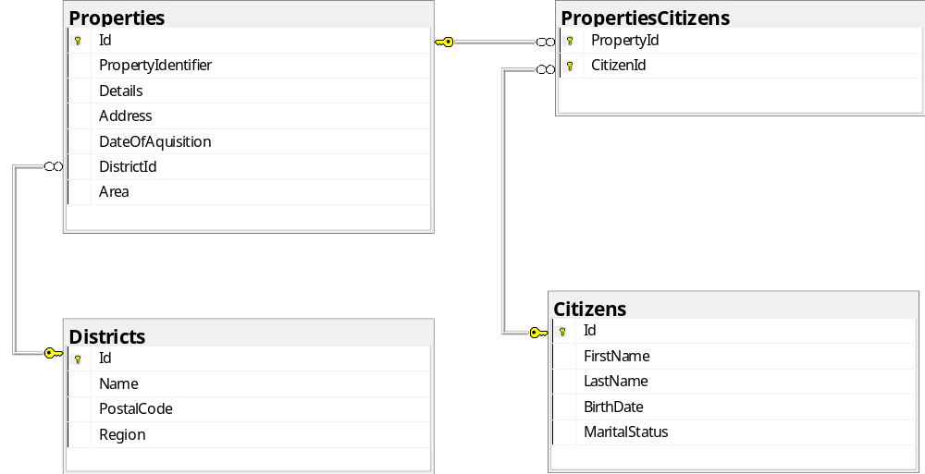

Project Skeleton Overview
You are given a project skeleton, which includes the following folders:
- Data – contains the CadastreContext class, Models folder, which contains the entity classes and the Configuration class with connection string
- DataProcessor – contains the Serializer and Deserializer classes, which are used for importing and exporting data
- Datasets – contains the .json and .xml files for the import part
- ImportResults – contains the import results you make in the Deserializer class
- ExportResults – contains the export results you make in the Serializer class

Model Definition (50 pts)
The application needs to store the following data:

District
- Id – integer, Primary Key
- Name – text with length [2, 80] (required)
- PostalCode – text with length 8. All postal codes must have the following structure:starting with two capital letters, followed by e dash '-', followed by five digits. Example: SF-10000 (required)
- Region – Region enum (SouthEast = 0, SouthWest, NorthEast, NorthWest) (required)
- Properties - collection of type Property

Property
- Id – integer, Primary Key
- PropertyIdentifier – text with length [16, 20] (required)
- Area – int not negative (required)
- Details - text with length [5, 500] (not required)
- Address – text with length [5, 200] (required)
- DateOfAcquisition – DateTime (required)
- DistrictId – integer, foreign key (required)
- District – District
- PropertiesCitizens - collection of type PropertyCitizen

Citizen
- Id – integer, Primary Key
- FirstName – text with length [2, 30] (required)
- LastName – text with length [2, 30] (required)
- BirthDate – DateTime (required)
- MaritalStatus - MaritalStatus enum (Unmarried = 0, Married, Divorced, Widowed) (required)
- PropertiesCitizens - collection of type PropertyCitizen

PropertyCitizen
- PropertyId – integer, Primary Key, foreign key (required)
- Property – Property
- CitizenId – integer, Primary Key, foreign key (required)
- Citizen – Citizen

Data Import (25pts)
For the functionality of the application, you need to create several methods that manipulate the database. The project skeleton already provides you with these methods, inside the Deserializer class. Usage of Data Transfer Objects and AutoMapper is optional.
Use the provided JSON and XML files to populate the database with data. Import all the information from those files into the database.
You are not allowed to modify the provided JSON and XML files.
If a record does not meet the requirements from the first section, print an error message:
Error message
Invalid Data!

XML Import

Import Districts
Using the file "Districts.xml", import the data from the file into the database. Print information about each imported object in the format described below.

Constraints
- If there are any validation errors for the district entity (such as invalid name, invalid postal code), do not import any part of the entity and append an error message to the method output.
- If there is already added a district with the same name in the database, do not duplicate the record. Do not import any part of the entity and append an error message to the method output.
- If there are any validation errors for the property entity (such as invalid property identifier, details , address), do not import only the property entity and append an error message to the method output.
  - The DateTime data in the document will be in the following fomat: "dd/MM/yyyy"
  - Make sure you use CultureInfo.InvariantCulture
- If the database or the current district contains another property with the same PropertyIdentifier, the property should not be duplicated. Do not import only the property entity and append an error message to the method output.
- If the database or the current district contains another property with the same Address, do not import the property entity and append an error message to the method output.
Success message
Successfully imported district - {districtName} with {propertiesCount} properties.

Example
Districts.xml
<?xml version="1.0" encoding="utf-8" ?>
<Districts>
<District Region="SouthWest">
<Name>Sofia</Name>
<PostalCode>SF-10000</PostalCode>
<Properties>
<Property>
<PropertyIdentifier>SF-10000.001.001.001</PropertyIdentifier>
<Area>71</Area>
<Details>One-bedroom apartment</Details>
<Address>Apartment 5, 23 Silverado Street, Sofia</Address>
<DateOfAcquisition>15/03/2022</DateOfAcquisition>
</Property>
<Property>
<PropertyIdentifier>SF-10000.003.002.001</PropertyIdentifier>
<Area>120</Area>
<Details>Spacious two-bedroom apartment near central park</Details>
<Address>Apartment 8, 47 Green Street, Sofia</Address>
<DateOfAcquisition>01/02/2022</DateOfAcquisition>
</Property>
<Property>
<PropertyIdentifier>SF-10000.004.002.002</PropertyIdentifier>
<Area>150</Area>
<Details>Luxury penthouse with panoramic city views</Details>
<Address>Penthouse 2, 55 High Tower Road, Sofia</Address>
<DateOfAcquisition>10/02/2023</DateOfAcquisition>
</Property>
…
<Properties>
…
</District>
…
</Districts>
Output
Successfully imported district - Sofia with 5 properties.
Successfully imported district - Plovdiv with 4 properties.
Successfully imported district - Varna with 5 properties.
Successfully imported district - Burgas with 5 properties.
Successfully imported district - Blagoevgrad with 4 properties.
Successfully imported district - Veliko Tarnovo with 4 properties.
...
Upon correct import logic, you should have imported 27 districts and 117 properties.

JSON Import

Import Citizens
Using the file "Citizens.json", import the data from that file into the database. Print information about each imported object in the format described below.

Constraints
- If there any validation errors occur for the citizen entity (such as invalid first or last name, marital status value(check if string is "Unmarried" ||"Married" || "Divorced" || "Widowed")), do not import any part of the entity and append an error message to the method output.
  - The DateTime data in the document will be in the following fomat: "dd-MM-yyyy"
  - Make sure you use CultureInfo.InvariantCulture
Success message
Successfully imported citizen - {citizenFirstName} {citizenLastName} with {propertiesCount} properties.

Example
Properties.json
[
{
"FirstName": "Ivan",
"LastName": "Georgiev",
"BirthDate": "12-05-1980",
"MaritalStatus": "Married",
"Properties": [ 17, 29 ]
},
{
"FirstName": "Stefan",
"LastName": "Dimitrov",
"BirthDate": "22-08-1972",
"MaritalStatus": "Divorced",
"Properties": [ 33, 47 ]
},
{
"FirstName": "Elena",
"LastName": "Petrova",
"BirthDate": "03-03-1985",
"MaritalStatus": "Unmarried",
"Properties": [ 12, 54, 60 ]
},
…
]
Output
Succefully imported citizen - Ivan Georgiev with 2 properties.
Succefully imported citizen - Stefan Dimitrov with 2 properties.
Succefully imported citizen - Elena Petrova with 3 properties.
Succefully imported citizen- Nikolai Vasilev with 2 properties.
Succefully imported citizen - Dimitrina Ilieva with 2 properties.
Invalid Data!
...
Upon correct import logic, you should have imported 76 citizens with 156 propertiesCitizens.

Data Export (25 pts)
Use the provided methods in the Serializer class. Usage of Data Transfer Objects and AutoMapper is optional.

JSON Export

Export Properties with Their Owners
Select all the properties from that have date of acquisition equal or later than 01/01/2000. Select them with their property identifier, area, address, date of acquisituon and owners(all citizens related to the property). For the citizens, export their last name and marital status. Order the properties by date of aquisition (descending) and then by property identifier (alphabetically, ascending). Foreach property order the citizens by last name(alphabetically, acsending).

Example
Serializer.ExportPropertiesWithOwners(CadastreContext dbContext)
[
{
"PropertyIdentifier": "SF-10000.004.002.002",
"Area": 150,
"Address": "Penthouse 2, 55 High Tower Road, Sofia",
"DateOfAcquisition": "10/02/2023",
"Owners": [
{
"LastName": "Petrov",
"MaritalStatus": "Married"
},
{
"LastName": "Todorov",
"MaritalStatus": "Married"
}
]
},
{
"PropertyIdentifier": "SF-10000.006.003.002",
"Area": 100,
"Address": "Apartment 21, 33 Family Street, Sofia",
"DateOfAcquisition": "15/07/2022",
"Owners": [
{
"LastName": "Iliev",
"MaritalStatus": "Married"
}
]
},…
]

XML Export

Export All Properties Larger Than 100 sq.m. with District
Export all properties that have area equal or larger than 100 square meters. Select them with their property identifier, area and date of acquisition. For each property, export its related district with its postal code. Order the properties by area (descending), then by date of acquisition (ascending).

Example
Serializer.ExportFilteredPropertiesWithDistrict(CadastreContext dbContext)
<?xml version="1.0" encoding="utf-16"?>
<Properties>
<Property postal-code="VA-90000">
<PropertyIdentifier>VA-90000.003.005.005</PropertyIdentifier>
<Area>2300</Area>
<DateOfAcquisition>28/08/2008</DateOfAcquisition>
</Property>
<Property postal-code="ST-60000">
<PropertyIdentifier>ST-60000.004.002.002</PropertyIdentifier>
<Area>1150</Area>
<DateOfAcquisition>14/06/2002</DateOfAcquisition>
</Property>
<Property postal-code="PL-40000">
<PropertyIdentifier>PL-40000.002.004.004</PropertyIdentifier>
<Area>1050</Area>
<DateOfAcquisition>03/03/2010</DateOfAcquisition>
</Property>
…
</Properties>

