Database Basics MS SQL Exam Preparation
Submit your solutions in the SoftUni Judge system at Judge.

Library Database

Section 1. DDL (30 pts)
You have been given the E/R Diagram of the LibraryDb database.
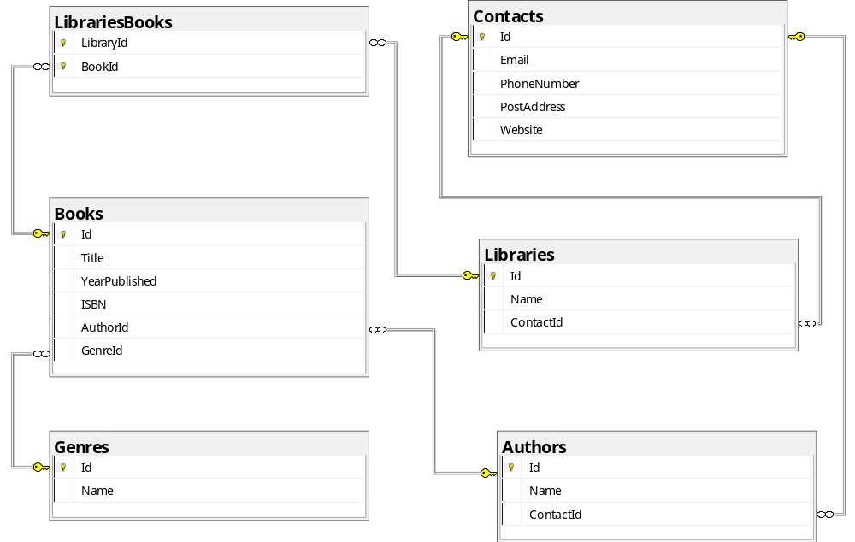
Create a database called LibraryDb. You need to create 6 tables:
- Books – contains information about each book;
- Authors – contains information about the authors of the books;
- Libraries – contains information about each library;
- Genres – contains information about the book’s category;
- Contacts – contains information about the contact methods with the libraries or the authors;
- LibrariesBooks - manages the many-to-many relationship between libraries and books, indicating which libraries store specific books and which books are stored in a specific library;
NOTE: Keep in mind that Judge doesn't accept "ALTER" statements and square brackets naming (when the names are not keywords).
NOTE: Please keep in mind that in case you have to work with a date, you have to use the same data type, described in the models tables. If you don't use the correct type, the Judge system won't accept your submission as correct.

You have been tasked to create the tables in the database by the following models:

Books
Column Name | Data Type | Constraints
Id | Integer from 0 to 2,147,483,647 | PK, Unique table identification, Identity
Title | String up to 100 symbols, Unicode | Null is not allowed
YearPublished | Integer from 0 to 2,147,483,647 | Null is not allowed
ISBN | String up to 13 symbols, Unicode | Unique, Null is not allowed
AuthorId | Integer from 0 to 2,147,483,647 | Relationship with table Authors, Null is not allowed
GenreId | Integer from 0 to 2,147,483,647 | Relationship with table Genres, Null is not allowed

Authors
Column Name | Data Type | Constraints
Id | Integer from 0 to 2,147,483,647 | PK, Unique table identification, Identity
Name | String up to 100 symbols, Unicode | Null is not allowed
ContactId | Integer from 0 to 2,147,483,647 | Relationship with table Contacts, Null is not allowed

Libraries
Column Name | Data Type | Constraints
Id | Integer from 0 to 2,147,483,647 | PK, Unique table identification, Identity
Name | String up to 50 symbols, Unicode | Null is not allowed
ContactId | Integer from 0 to 2,147,483,647 | Relationship with table Contacts, Null is not allowed

Genres
Column Name | Data Type | Constraints
Id | Integer from 0 to 2,147,483,647 | PK, Unique table identification, Identity
Name | String up to 30 symbols, Unicode | Null is not allowed

Contacts
Column Name | Data Type | Constraints
Id | Integer from 0 to 2,147,483,647 | PK, Unique table identification, Identity
Email | String up to 100 symbols, Unicode | Null is allowed
PhoneNumber | String up to 20 symbols, Unicode | Null is allowed
PostAddress | String up to 200 symbols, Unicode | Null is allowed
Website | String up to 50 symbols, Unicode | Null is allowed

LibrariesBooks
Column Name | Data Type | Constraints
LibraryId | Integer from 0 to 2,147,483,647 | PK, Unique table identification, Relationship with table Libraries, Null is not allowed
BookId | Integer from 0 to 2,147,483,647 | PK, Unique table identification, Relationship with table Books, Null is not allowed

Database design
Submit all of your CREATE statements to Judge (only the creation of tables).

Section 2. DML (10 pts)
Before you start, you have to import "Dataset.sql ". If you have created the structure correctly, the data should be successfully inserted.
In this section, you have to do some data manipulations:

Insert
Let's insert some sample data into the database. Write a query to add the following records to the corresponding tables. All IDs (Primary Keys) should be auto-generated.

Contacts
Id | Email | PhoneNumber | PostAddress | Website
21 | NULL | NULL | NULL | NULL
22 | NULL | NULL | NULL | NULL
23 | 'stephen.king@example.com' | '+4445556666' | '15 Fiction Ave, Bangor, ME' | 'www.stephenking.com'
24 | 'suzanne.collins@example.com' | '+7778889999' | '10 Mockingbird Ln, NY, NY' | 'www.suzannecollins.com'

Authors
Id | Name | ContactId
16 | 'George Orwell' | 21
17 | 'Aldous Huxley' | 22
18 | 'Stephen King' | 23
19 | 'Suzanne Collins' | 24

Books
Id | Title | YearPublished | ISBN | AuthorId | GenreId
36 | '1984' | 1949 | '9780451524935' | 16 | 2
37 | 'Animal Farm' | 1945 | '9780451526342' | 16 | 2
38 | 'Brave New World' | 1932 | '9780060850524' | 17 | 2
39 | 'The Doors of Perception' | 1954 | '9780060850531' | 17 | 2
40 | 'The Shining' | 1977 | '9780307743657' | 18 | 9
41 | 'It' | 1986 | '9781501142970' | 18 | 9
42 | 'The Hunger Games' | 2008 | '9780439023481' | 19 | 7
43 | 'Catching Fire' | 2009 | '9780439023498' | 19 | 7
44 | 'Mockingjay' | 2010 | '9780439023511' | 19 | 7

LibrariesBooks
LibraryId | BookId
1 | 36
1 | 37
2 | 38
2 | 39
3 | 40
3 | 41
4 | 42
4 | 43
5 | 44

Update
For all authors who do not have a website listed in their contact information, update their contact information to include a website. The website should be in the format: "www." + "authorname" + ".com"
'authorname' -> in lowercase without spaces
'George Orwell' -> www.georgeorwell.com

Delete
You are required to delete 'Alex Michaelides' from the Authors table. This is challenging because the Authors table is referenced by the Books table, which in turn is referenced by the LibrariesBooks table. Therefore, you need to handle these references correctly to maintain the integrity of the database.

Section 3. Querying (40 pts)
You need to start with a fresh dataset, so recreate your DB and import the sample data again ("Dataset.sql").

Books by Year of Publication
Select all books, ordered by year of publication – descending, and then by title - alphabetically.
Required columns:
- Book Title
- ISBN
- YearReleased

Example
Book Title | ISBN | YearReleased
'The Silent Patient' | '9781250301697' | 2019
'Becoming' | '9781524763138' | 2018
'Educated' | '9780399590504' | 2018
'The Great Alone' | '9780312577230' | 2018
'Where the Crawdads Sing' | '9780735219090' | 2018
'A Storm of Swords' | '9780553106633' | 2000
… | …

Books by Genre
Select all books with 'Biography' or 'Historical Fiction' genres. Order results by Genre, and then by book title – alphabetically.
Required columns:
- Id
- Title
- ISBN
- Genre

Example
Id | Title | ISBN | Genre
3 | Becoming | 9781524763138 | Biography
25 | Anna Karenina | 9780143035008 | Historical Fiction
33 | Crime and Punishment | 9780140449136 | Historical Fiction
… | … | … | …

Libraries Missing Specific Genre
Select all libraries that do not have any books of a specific genre ('Mystery'). Order the results by the name of the library in ascending order.
Required columns:
- Library
- Email

Example
Library | Email
Politics and Prose | politics@example.com
Powell's City of Books | powells@example.com
Strand Bookstore | strand@example.com
Tattered Cover | tattered@example.com

First 3 Books
Your task is to write a query to select the first 3 books from the library database (LibraryDb) that meet the following criteria:
- The book was published after the year 2000 and contains the letter 'a' in the book title,
- OR
- The book was published before 1950 and the genre name contains the word 'Fantasy'.
The results should be ordered by the book title in ascending order, and then by the year published in descending order.
Required columns:
- Title
- Year
- Genre

Example
Title | Year | Genre
Educated | 2018 | Memoir
The Great Alone | 2018 | Historical Fiction
The Hobbit | 1937 | Fantasy

Authors from the UK
Your task is to write a query to select all authors from the UK (their PostAddress contains 'UK'). The address information is stored in the Contacts table under the PostAddress column. The results should be ordered by the author's name in ascending order.
Required columns:
- Author
- Email
- Address

Example
Author | Email | Address
J.K. Rowling | jk@example.com | 100 Kings Rd, London, UK
J.R.R. Tolkien | jrr@example.com | 221B Baker St, London, UK

Fictions in Denver
Your task is to write a query to select details for books of a specific genre -'Fiction', and are sold in libraries located in Denver - their PostAddress contains 'Denver'. Order the result by book title – alphabetically.
Required columns:
- Author
- Title
- Library
- Library Address

Example
Author | Title | Library | Library Address
Charles Dickens | A Tale of Two Cities | Tattered Cover | 2526 E Colfax Ave, Denver, CO
Charles Dickens | Great Expectations | Tattered Cover | 2526 E Colfax Ave, Denver, CO

Section 4. Programmability (20 pts)

Authors with Books
Create a user-defined function, named udf_AuthorsWithBooks(@name) that receives an author's name.
- The function will accept an author's name as a parameter
- It will join the relevant tables to count the total number of books by that author available in all libraries

Example
Query
SELECT dbo.udf_AuthorsWithBooks('J.K. Rowling')
Output
3

Search for Books from a Specific Genre
Create a stored procedure, named usp_SearchByGenre(@genreName) that receives a genre name as a parameter. The procedure must print full information about all books that belong to the specific genre. Order them by book title – alphabetically.
Required columns:
- Title
- Year
- ISBN
- Author
- Genre

Example
Query
EXEC usp_SearchByGenre 'Fantasy'
Output
Title | Year | ISBN | Author | Genre
Harry Potter and the Chamber of Secrets | 1998 | 9780747538493 | J.K. Rowling | Fantasy
Harry Potter and the Prisoner of Azkaban | 1999 | 9780747542155 | J.K. Rowling | Fantasy
… | … | … | … | …

Genre Filter
Create a user-defined function, named udf_GenreFilter(@genre) that returns all books of a given genre. The function should accept a genre name as input and return a table with the following columns:
- BookTitle
- YearPublished
- ISBN
- LibraryNametas

Example
Query
SELECT dbo.udf_GenreFilter('Fiction')
BookId | Title | YearPublished | ISBN | Author | Library
2 | Where the Crawdads Sing | 2018 | 9780735219090 | Delia Owens | City Lights
27 | Moby-Dick | 1851 | 9780142437247 | Herman Melville | City Lights
… | … | … | … | … | …

