03. Vending Machine
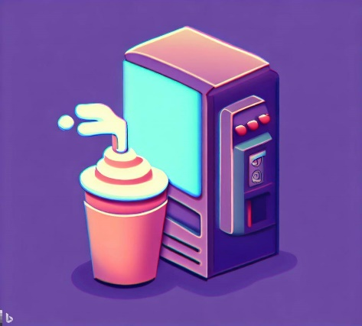
You are tasked with creating a program that simulates a vending machine for hot drinks. The vending machine should be able to store and dispense various types of hot drinks. You should create the necessary classes and methods to implement this functionality.

Preparation
Download the skeleton provided in Judge. Do not change the StartUp class or its namespace.
Pay attention to name the project VendingSystem, all the classes, their fields, and methods the same way they are presented in the following document. It is also important to keep the project structure as described.

Problem Description
Your task is to create a repository that stores drinks by creating the classes described below.

Drink
You are given a class Drink with the following properties:
- Name – string
- Price - decimal
- Volume - int
The class constructor should receive name, price and volume.
Override the ToString() method in the following format:
"Name: {Name}, Price: ${Price}, Volume: {Volume} ml"

VendingMachine
Next, you are given a class VendingMachine that has Drinks (a List that stores Drinks). The VendingMachine class should have the following properties:
- ButtonCapacity - int
- Drinks – List<Drink>
- GetCount - int - returns the number of drinks, available in the Vending machine.
The class constructor should receive buttonCapacity, also it should initialize the Drinks with a new instance of the collection.
Implement the following features:
- Method AddDrink(Drink drink) – adds an entity to the collection of Drinks, if the Capacity allows it.
- Method RemoveDrink(string name) – removes a drink by given name, if such exists, and returns boolean (true if it is removed, otherwise – false)
- Method GetLongest() – returns the Drink with the biggest value of Volume property.
- Method GetCheapest() – returns the Drink with the lowest value of Price property.
- Method BuyDrink(string name) - returns a string in the format of the overriden ToString() method.
- Method Report() – returns a string in the following format:
  - "Drinks available:
{Drink1}
{Drink2}
(…)"

Constraints
- The names of the drinks will be always unique.
- You will always have drinks added before receiving methods, manipulating the drinks in the VendingMachine.

Examples
This is an example of how the VendingMachine class is intended to be used.
Sample code usage
//Initialize the repository (VendingMachine)
VendingMachine vendingMachine = new VendingMachine(6);
//Initialize entity (Drink)
Drink tea = new Drink("Tea", 1.5m, 300);
Drink coffee = new Drink("Coffee", 2.0m, 120);
Drink hotChocolate = new Drink("Hot Chocolate", 2.5m, 200);
Drink latte = new Drink("Latte", 3.5m, 220);
Drink cappuccino = new Drink("Cappuccino", 2.8m, 180);
Drink mocha = new Drink("Mocha", 2.1m, 150);
Drink herbalTea = new Drink("Herbal Tea", 1.75m, 300);
//Get Count
Console.WriteLine(vendingMachine.GetCount);
//0
//Add Drinks
vendingMachine.AddDrink(tea);
vendingMachine.AddDrink(coffee);
vendingMachine.AddDrink(hotChocolate);
vendingMachine.AddDrink(latte);
vendingMachine.AddDrink(cappuccino);
vendingMachine.AddDrink(mocha);
//Try to add drinks when the capacity is full
vendingMachine.AddDrink(herbalTea);

//Get Count
Console.WriteLine(vendingMachine.GetCount);
//6
//Remove Drink
Console.WriteLine(vendingMachine.RemoveDrink("Herbal Tea"));//False
Console.WriteLine(vendingMachine.RemoveDrink("Tea"));//True
//Get Longest Drink
Console.WriteLine(vendingMachine.GetLongest());
//Name: Latte, Price: $3.5, Volume: 220 ml

//Get Cheapest Drink
Console.WriteLine(vendingMachine.GetCheapest());
//Name: Coffee, Price: $2.0, Volume: 120 ml

//Buy a specific Drink
Console.WriteLine(vendingMachine.BuyDrink("Cappuccino"));
//Name: Cappuccino, Price: $2.8, Volume: 180 ml

//Drinks Report
Console.WriteLine(vendingMachine.Report());
//Drinks available:
//Name: Coffee, Price: $2.0, Volume: 120 ml
//Name: Hot Chocolate, Price: $2.5, Volume: 200 ml
//Name: Latte, Price: $3.5, Volume: 220 ml
//Name: Cappuccino, Price: $2.8, Volume: 180 ml
//Name: Mocha, Price: $2.1, Volume: 150 ml

Submission
Zip all the files in the project folder except bin and obj folders.

