03. Shark Taxonomy
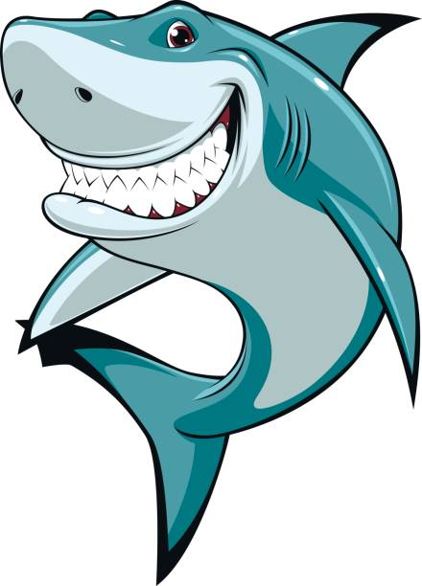
Let's dive into the amazing world of the ocean, where we'll meet some incredible creatures called sharks. Sharks come in many different types, like hammerheads and reef sharks, and they each have their own unique features. In the 'Sharks Taxonomy' challenge, we'll create a list to keep track of these cool underwater animals and learn more about them.

Preparation
Download the provided skeleton in Judge. Do not change the StartUp class or its namespace.
Ensure that the project is named SharkTaxonomy, and all classes, fields, and methods should be named exactly as presented in the document. Maintain the project structure as described below.

Problem description
Your task is to create a repository that stores sharks by implementing the following classes.

Shark
First, create a class Shark with the following properties:
- Kind - string
- Length - int
- Food - string
- Habitat - string
The class constructor should receive kind, length, food and habitat.
Override the ToString() method in the following format:
"{Kind} shark: {Length}m long.
Could be spotted in the {Habitat}, typical menu: {Food}"

Classifier
Next, create a class Classifier that has Species (a collection for storing sharks). All entities inside the repository have the same properties. The Classifier class should have the following properties:
- Capacity - int
- Species - List<Shark>
- GetCount – getter => returns the number of all sharks.
The class constructor should receive capacity. Also, it should initialise the Species with a new instance of the collection.

Implement the following features:
- Method AddShark(Shark shark) – adds a Shark to the Species collection, if the Capacity allows it. If there is a Shark from the same Kind already added, do not duplicate sharks, just skip the command.
- Method RemoveShark(string kind) – attempts to find a Shark, within the Species collection, with Kind value, matching the given parameter. If no Shark is found, the method returns false. Otherwise, it is removed from the collection and the method returns true.
- Method GetLargestShark()– returns the ToString() value of the largest of all sharks, arranged by length.
- Method GetAverageLength() – returns the average length of the sharks added to the collection.
- Method Report() – returns a string in the following format:
  - "{count} sharks classified:
{shark₁}
{shark₂}
{…}
{shark_{n}}"

Constraints
- You will always have sharks added before receiving commands manipulating the collections in
the Classifier.
- There will always be a Shark that has the greatest value of Length property.

Examples
This is an example of how the Classifier class is intended to be used.
Sample code usage
//Initialize new repository (Classifier)
Classifier classifier = new(10);

//Initialize entities (Shark)
Shark greatWhite = new("Great White", 5, "Seals", "Open Ocean");
Shark hammerhead = new("Hammerhead", 4, "Fish", "Tropical Waters");
Shark tiger = new("Tiger", 4, "Turtles", "Coral Reefs");
Shark mako = new("Mako", 3, "Fish", "Open Ocean");
Shark bull = new("Bull", 3, "Fish", "Rivers");
Shark whale = new("Whale", 12, "Plankton", "Open Ocean");
Shark leopard = new("Leopard", 1, "Crabs", "Shallow Waters");
Shark goblin = new("Goblin", 4, "Deep-sea Creatures", "Deep Ocean");
Shark thresher = new("Thresher", 6, "Fish", "Open Ocean");
Shark blacktipReef = new("Blacktip Reef", 2, "Fish", "Coral Reefs");
Shark oceanicWhitetip = new("Oceanic Whitetip", 3, "Fish", "Open Ocean");

//Add sharks to the repository
classifier.AddShark(greatWhite);
classifier.AddShark(hammerhead);
classifier.AddShark(tiger);
classifier.AddShark(mako);
classifier.AddShark(bull);
classifier.AddShark(whale);
classifier.AddShark(leopard);
classifier.AddShark(goblin);
classifier.AddShark(thresher);
classifier.AddShark(blacktipReef);

//Check collection count
Console.WriteLine(classifier.GetCount);
//10

//Attempt to add a shark that will exceed the capacity of the Classifier
classifier.AddShark(oceanicWhitetip);

//Check collection count
Console.WriteLine(classifier.GetCount);
//10

//Remove existing shark
classifier.RemoveShark("Blacktip Reef"); //Returns True

//Check collection count
Console.WriteLine(classifier.GetCount);
//9

//Try to remove not existing shark
classifier.RemoveShark("Blue"); //Returns False

//Check collection count
Console.WriteLine(classifier.GetCount);
//9

//Try to add once again a shark, if there is enough capacity already
classifier.AddShark(oceanicWhitetip);

//Check collection count
Console.WriteLine(classifier.GetCount);
//10

//Get the shark that has the greatest body length
Console.WriteLine(classifier.GetLargestShark());
//Whale shark: 12m long.
//Could be spotted in the Open Ocean, typical menu: Plankton

//Get the average Length of all sharks added to the collection
Console.WriteLine(classifier.GetAverageLength());
//4.5

//Print Sharks Report
Console.WriteLine(classifier.Report());

//10 sharks classified:
//Great White shark: 5m long.
//Could be spotted in the Open Ocean, typical menu: Seals
//Hammerhead shark: 4m long.
//Could be spotted in the Tropical Waters, typical menu: Fish
//Tiger shark: 4m long.
//Could be spotted in the Coral Reefs, typical menu: Turtles
//Mako shark: 3m long.
//Could be spotted in the Open Ocean, typical menu: Fish
//Bull shark: 3m long.
//Could be spotted in the Rivers, typical menu: Fish
//Whale shark: 12m long.
//Could be spotted in the Open Ocean, typical menu: Plankton
//Leopard shark: 1m long.
//Could be spotted in the Shallow Waters, typical menu: Crabs
//Goblin shark: 4m long.
//Could be spotted in the Deep Ocean, typical menu: Deep - sea Creatures
//Thresher shark: 6m long.
//Could be spotted in the Open Ocean, typical menu: Fish
//Oceanic Whitetip shark: 3m long.
//Could be spotted in the Open Ocean, typical menu: Fish

Submission
Zip all the files in the project folder except bin and obj folders.

