ASP.NET Fundamentals Regular Exam – 19 October 2024


Problems for the retake exam for the "ASP.NET Core Fundamentals" course @ SoftUni

Welcome to DeskMarket
DeskMarket is your go-to platform for the latest in technology. Whether you're looking for high-performance laptops, powerful workstations, or top-tier accessories, DeskMarket has everything you need to elevate your work and play.

Technological Requirements and Overview
- Use the provided skeleton – DeskMarket-Skeleton.zip
- All of the needed packages have been installed.
The Technological Requirements are ABSOLUTE. If you do not follow them, you will NOT be scored for other Requirements.
The provided skeleton consists of:
- Areas/Identity/Pages – you have to scaffold Identity here
- Controllers – you should implement the controllers logic here
- Data – you should hold the entities models here
- Models – you should implement the models here
- Views – you are provided with the needed views. Your task is to implement some logic regarding the logged-in/logged-out user
- appsettings.json – don't forget to change the your connection string
- Program.cs – you should fulfil the security and password requirements here
NOTE: You should seed the database with provided in advance data regarding the Category entity. In order to do this, remove the comments from the block of code in the protected override void OnModelCreating(ModelBuilder builder) method of the DbContext.
NOTE: Don't forget to uncomment the code inside the views while you implement your logic.
Now that you know the Technological Requirements, let us see what the Functional Requirements are.

Identity Requirements
You should scaffold Identity and use the default IdentityUser.
Remove the unnecessary code from the Login.cshtml and Register.cshtml files and leave only the needed code in order for the app to be functioning correctly.
NOTE: Don't worry about the views' style – once you scaffold Identity and remove the unnecessary code, the Login and Register pages should look like shown below. Don't add any classes to the views of those two pages!
The password requirements for the IdentityUser are the following:
- Require confirmed account: false
- Require digits: false
- Require non-alphanumeric characters: false
- Required uppercase letters: false

Database Requirements
The Database of DeskMarket:

Product
- Has Id – a unique integer, Primary Key
- Has ProductName – a string with min length 2 and max length 60 (required)
- Has Description – string with min length 10 and max length 250 (required)
- Has Price – decimal in range[1.00m;3000.00m], (required)
- Has ImageUrl – nullable string (not required)
- Has SellerId – string (required)
- Has Seller – IdentityUser (required)
- Has AddedOn – DateTime with format "dd-MM-yyyy" (required)
  - The DateTime format is recommended, if you are having troubles with this one
  - You are free to use another one)
- Has CategoryId – integer, foreign key (required)
- Has Category – Category (required)
- Has IsDeleted – bool (default value == false)
- Has ProductsClients – a collection of type ProductClient
Feel free to use the new syntax for realization of the many-to-many relation without a mapping table.

Category
- Has Id – a unique integer, Primary Key
- Has Name – a string with min length 3 and max length 20 (required)
- Has Products – a collection of type Product

ProductClient
- Has ProductId – integer, PrimaryKey, foreign key (required)
- Has Product – Product
- Has ClientId – string, PrimaryKey, foreign key (required)
- Has Client – IdentityUser
Implement the entities with the correct datatypes and their relations.

Page Requirements

Index Page (logged-out user)
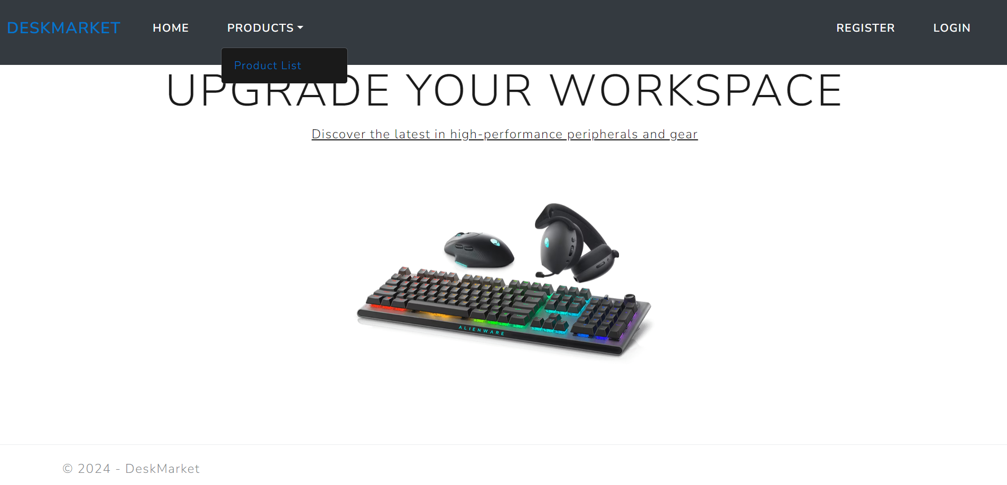

Index Page (logged-in user)
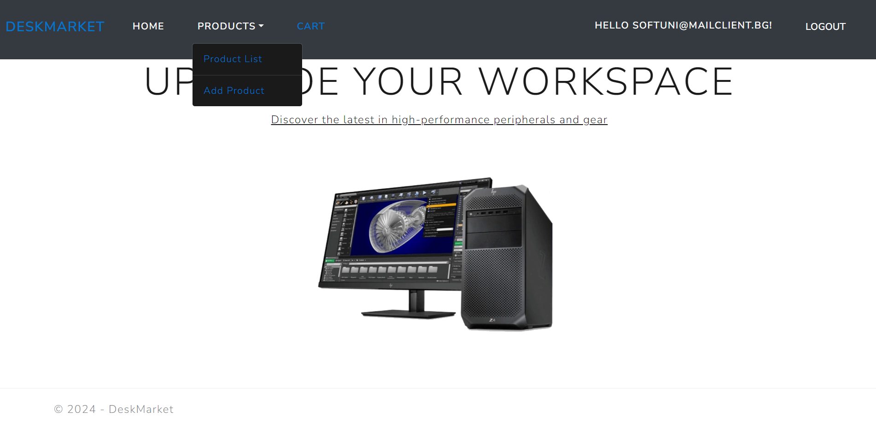

Login Page (logged-out user)
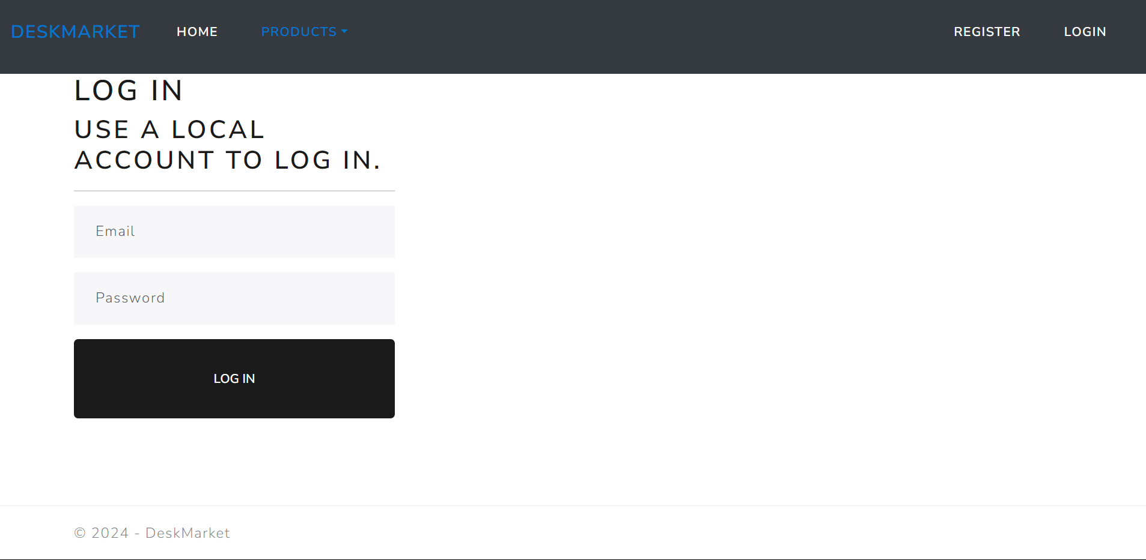

Register Page (logged-out user)
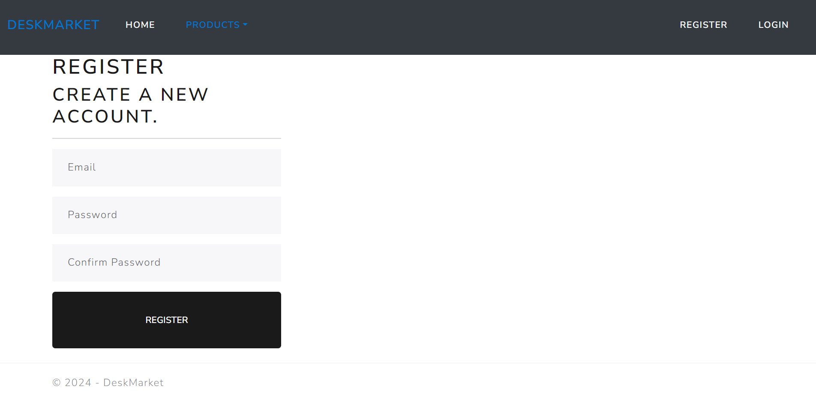

/Product/Add (logged-in user)
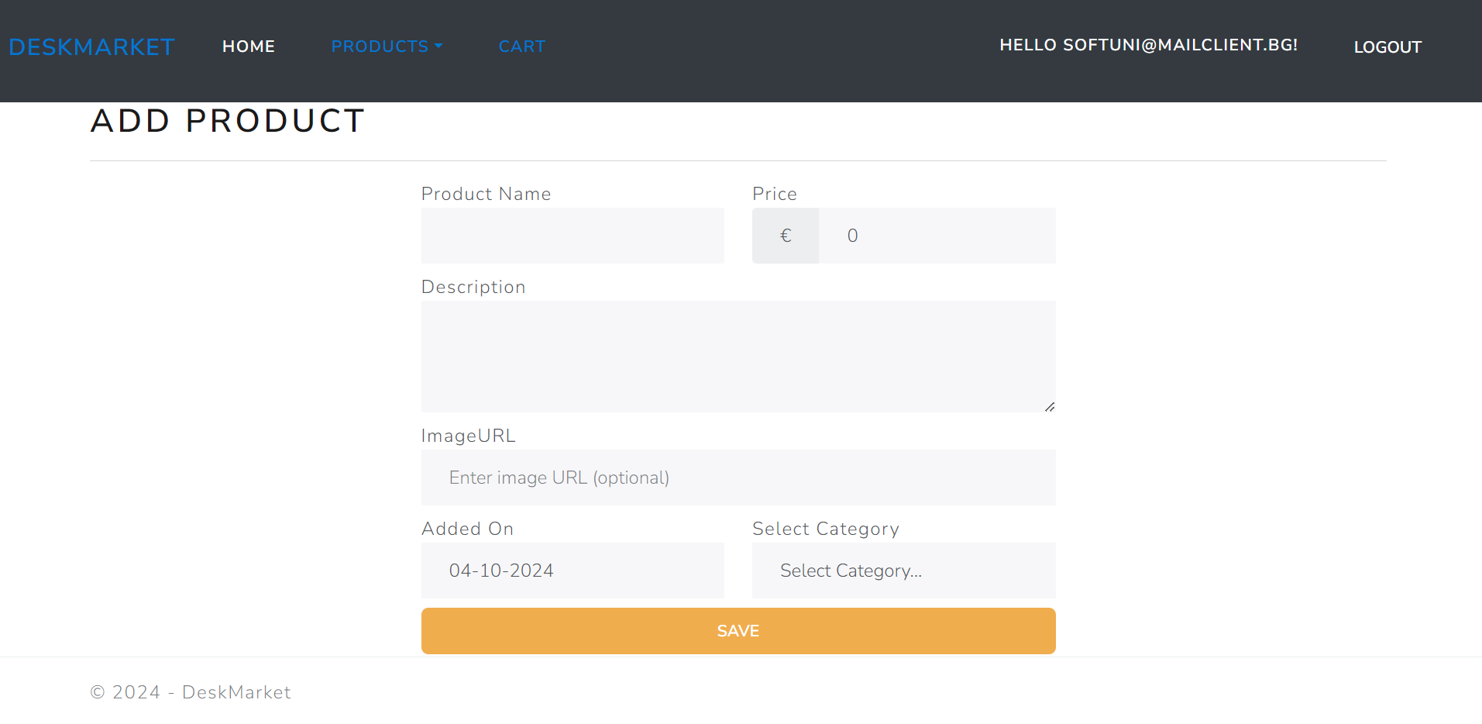
NOTE: the DateTime format is recommended, if you are having troubles with the one in the image, you are free to use another one.

/Product/Index (logged-out user)
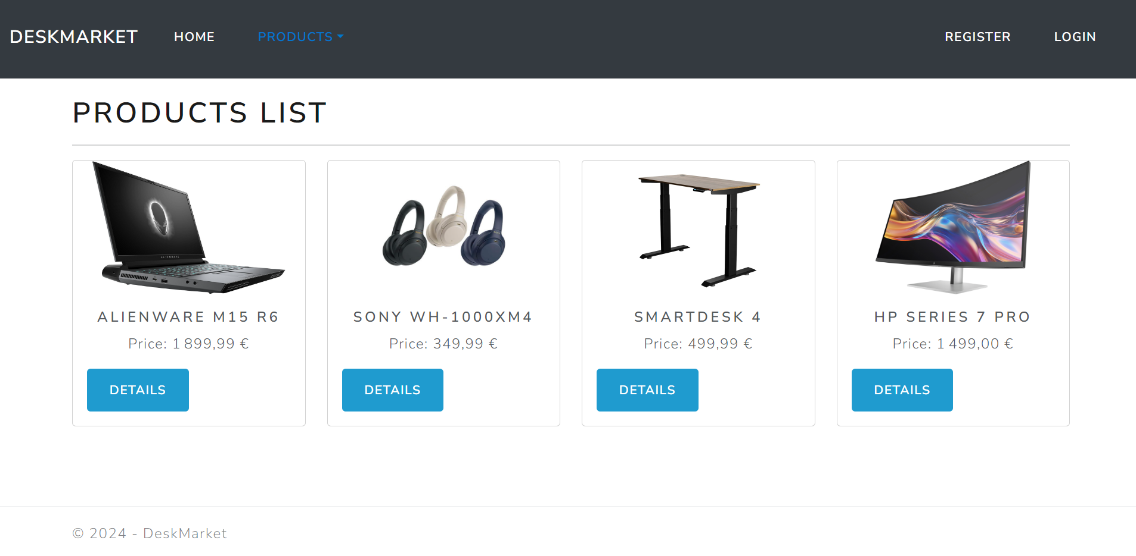
NOTE: If user is not logged in and tries to go to the Home page, the application must redirect them to the /Home/Index

/Product/Index (logged-in user)
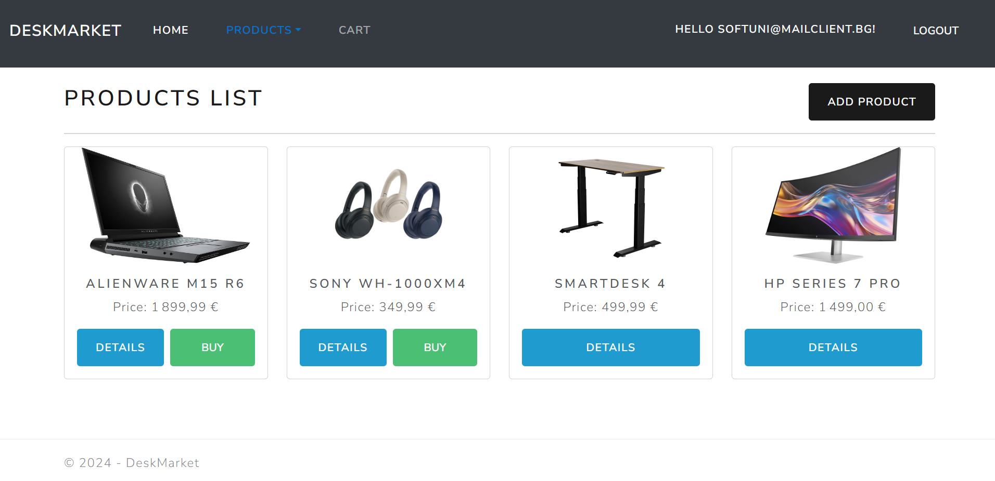
NOTE: If user is logged in and tries to go to the Home page, the application must redirect them to the /Product/Index

/Product/Cart (logged-in user)
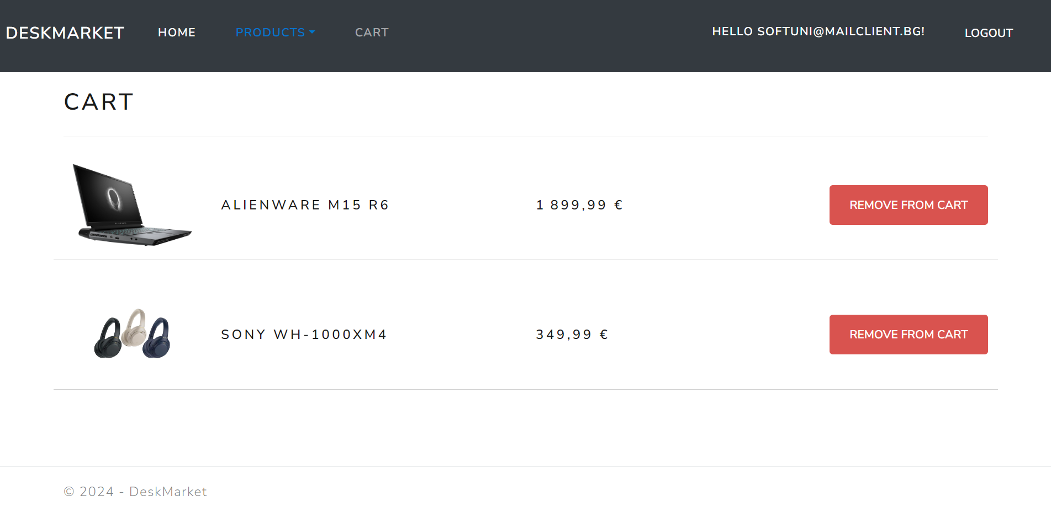

/Product/Edit/{id} (logged-in user)
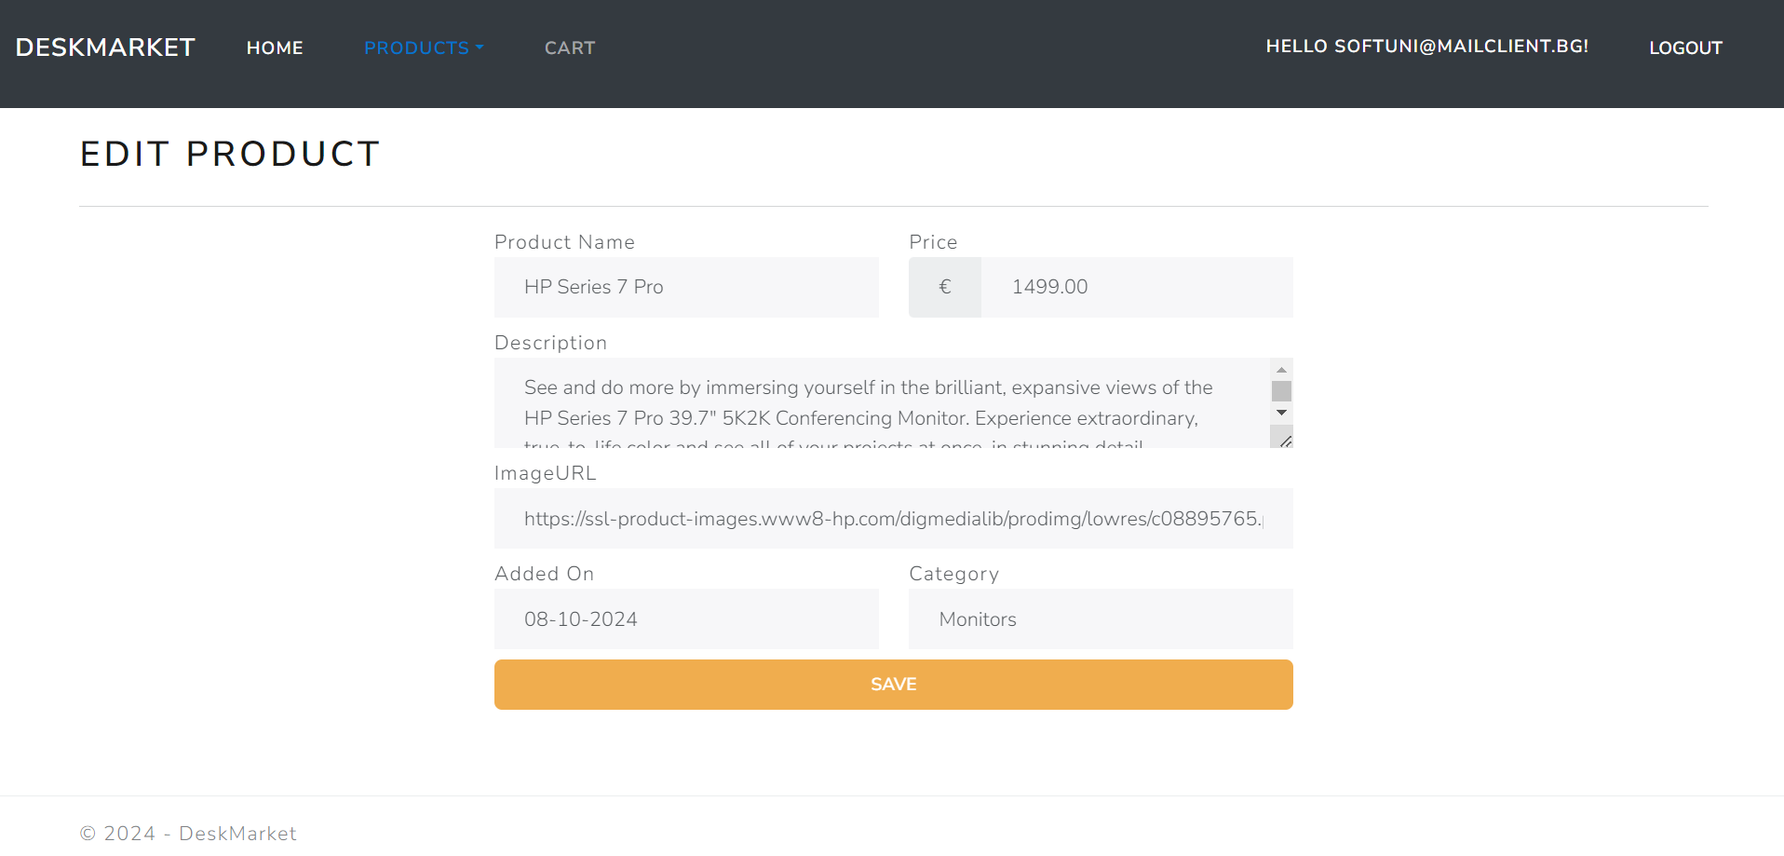
NOTE: the DateTime format is recommended, if you are having troubles with the one in the image, you are free to use another one.

/Product/AddToCart?id={id} (logged-in user)
This feature adds the selected product to the user's cart. If the product is already in the user's cart, it should not be added again. If the addition is successful, the users will be redirected to their cart page "/Product/Cart" page.

/Product/RemoveFromCart?id={id} (logged-in user)
This feature removes the selected product from the user's cart. If the removal is successful, the user will be redirected to their cart page "/Product/Cart" page.
NOTE: The templates should look EXACTLY as shown above.
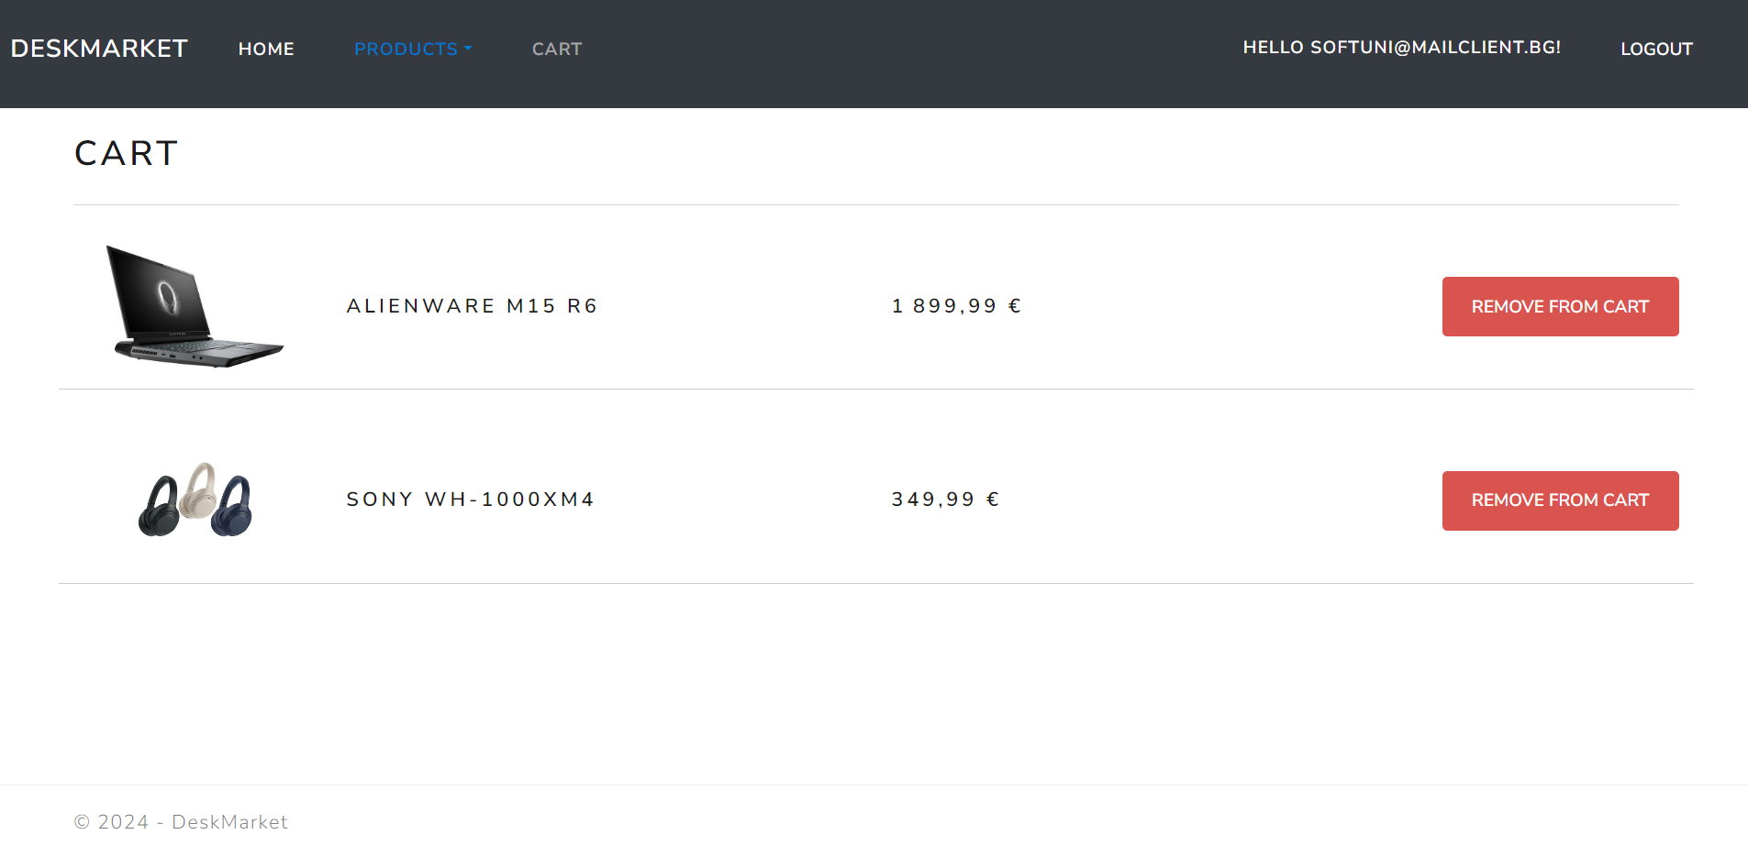
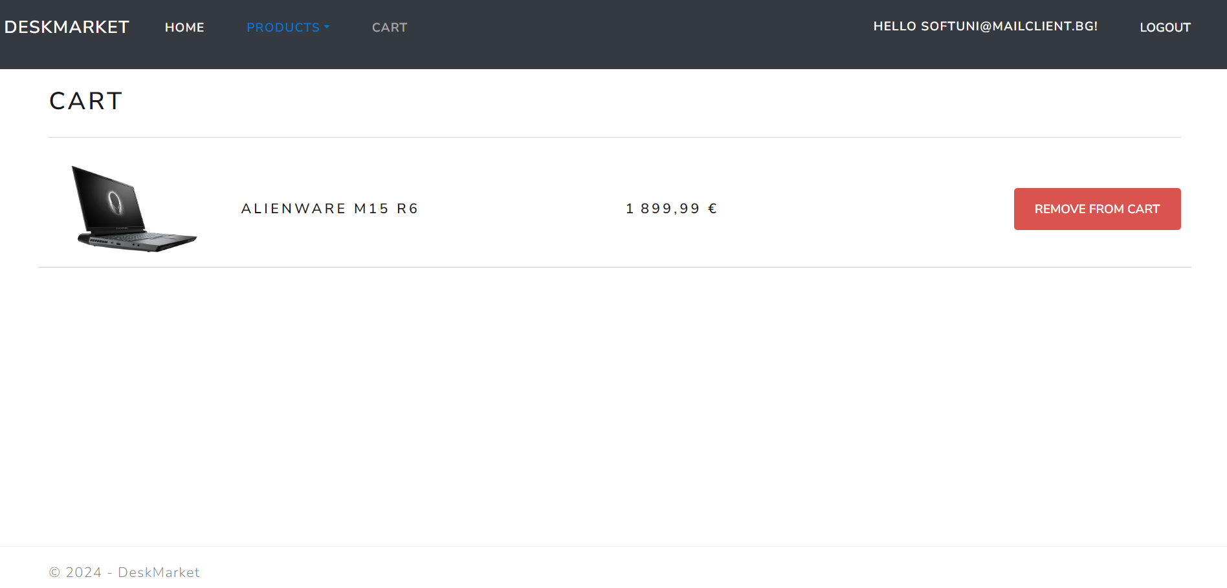
Product/Details/{id} (logged-in user, seller of a product)
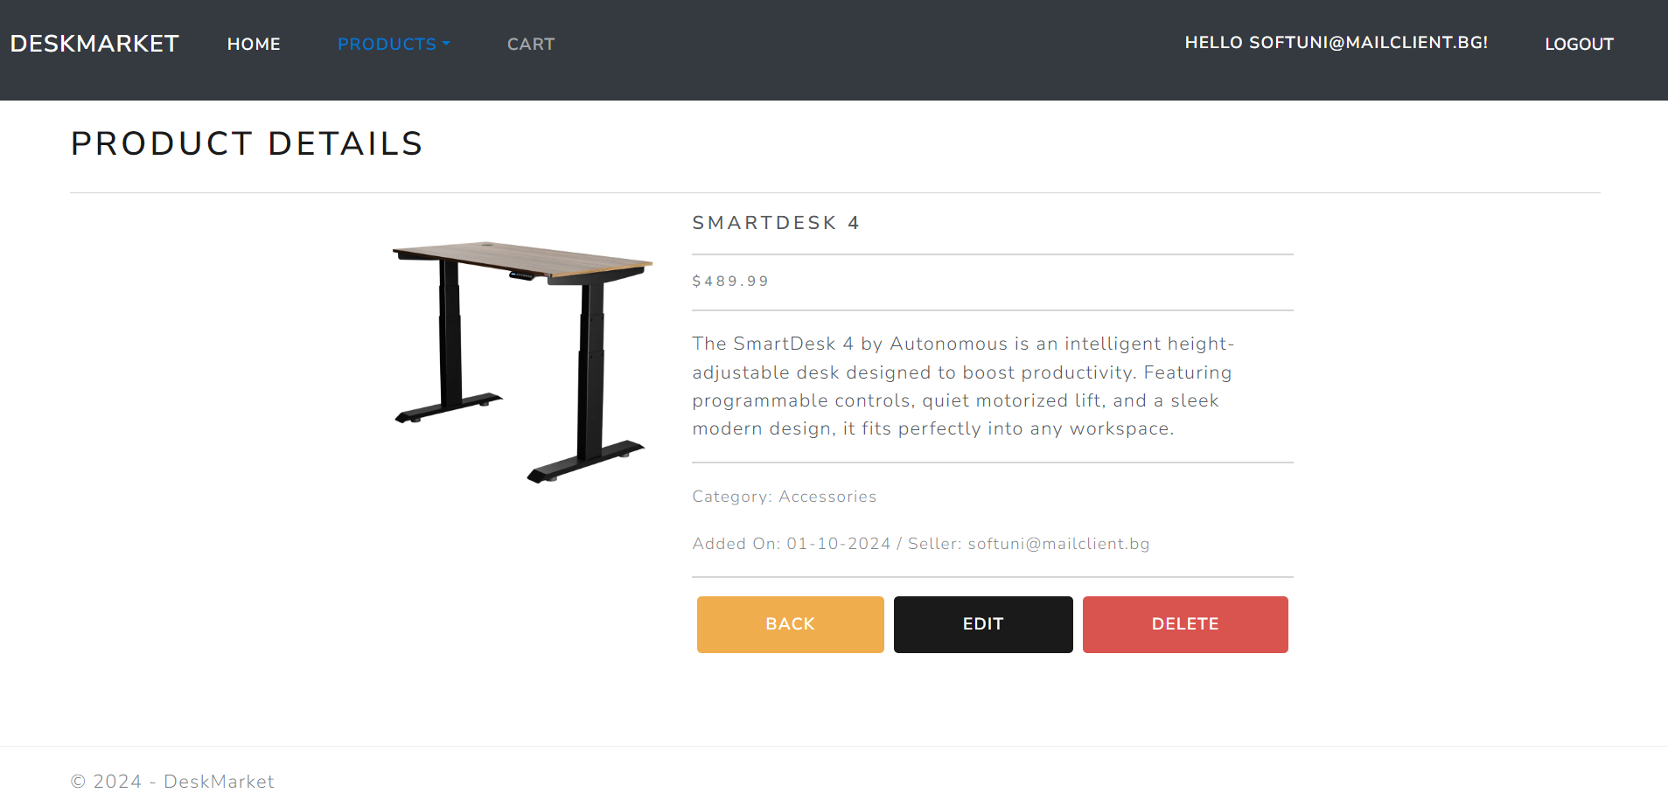
NOTE: If the currently logged-in user is the seller of the product, the "Delete" and "Edit" buttons should be visible, allowing them full access to the product functionalities.
However, if the logged-in user is not the seller of the game, the "Delete" and "Edit" buttons should not be visible. The "Buy" button should be visible. This ensures that the product seller and not-seller-user have different application functionalities access.
Guests (unauthenticated users) should be able to access the product details page but won't have access to actions like buying, editing, or deleting a product.
Product/Details/{id} (logged-in user, not a seller of a product)
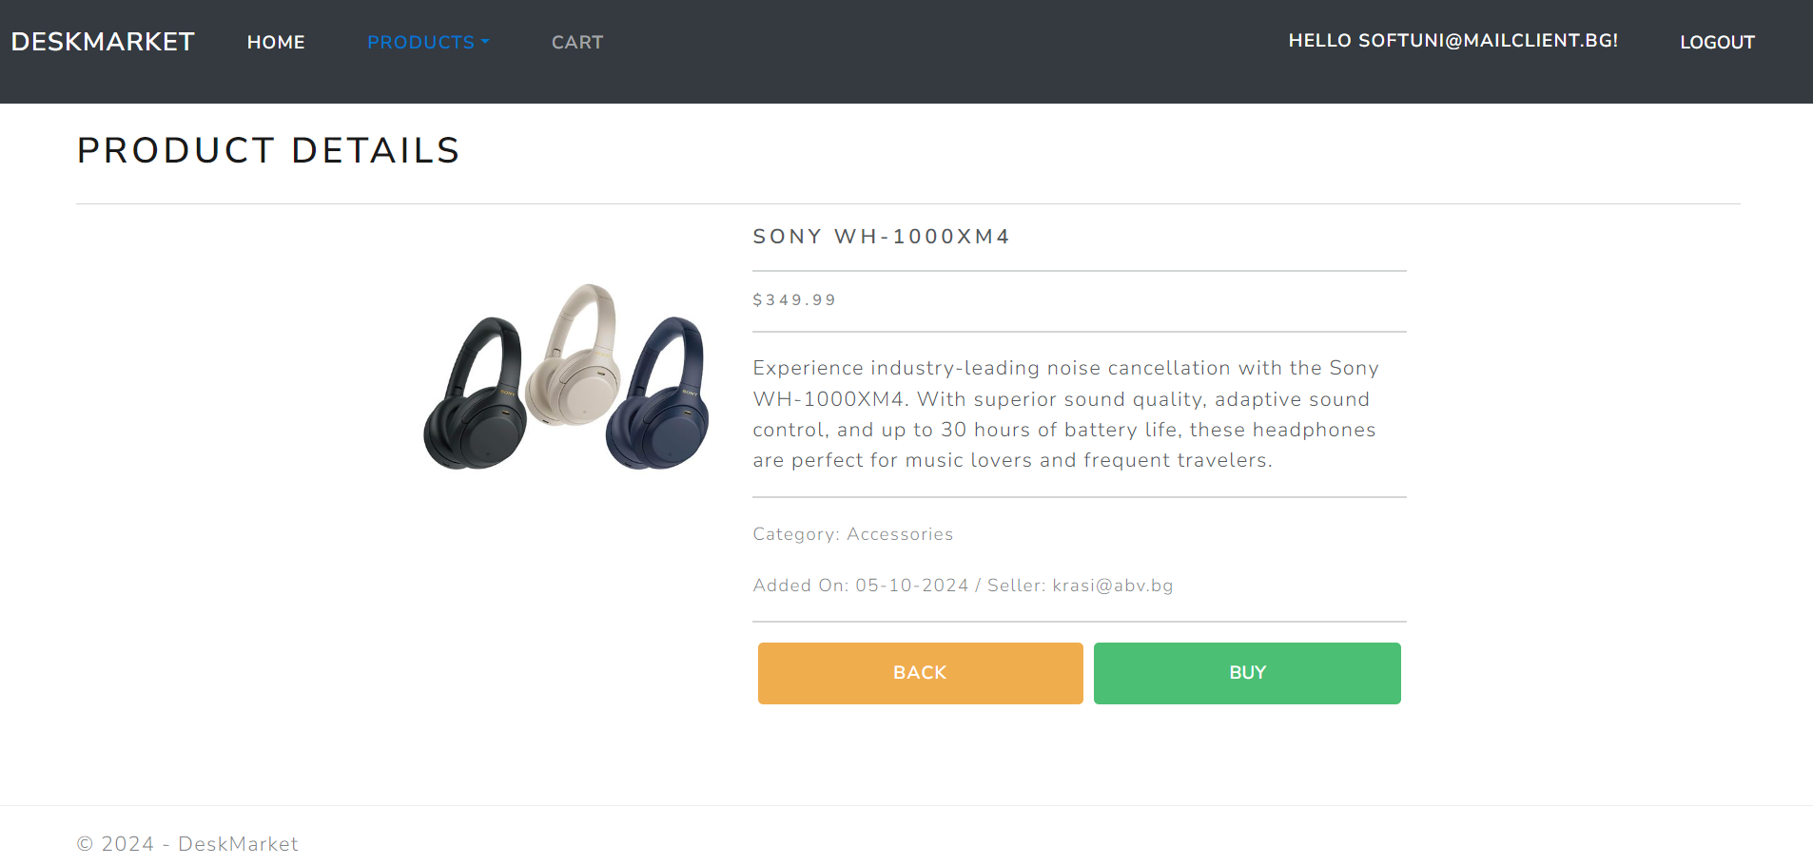
Product/Details/{id} (guest user, not logged-in)
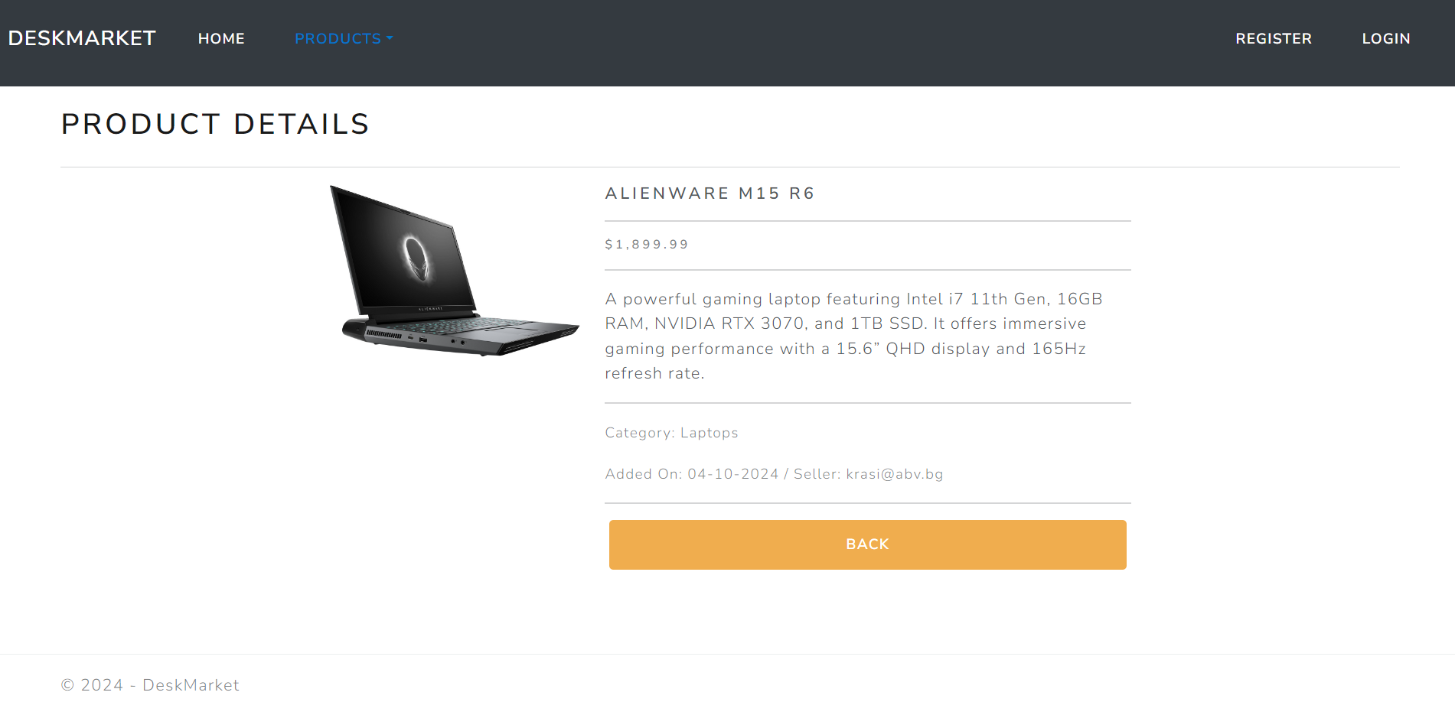
Product/Delete/{id} (logged-in user, seller of a product)
When the logged-in user who is the seller of a product accesses this page, they will be able to initiate the deletion of a product. However, this is a soft delete process, meaning that the product will remain in the database but
will no longer appear in the product listings. The product can no longer be bought or viewed by users, effectively removing it from the storefront.
After confirming the delete, the seller will be redirected to the product controller, index action. This process is one-directional and irreversible through the user interface, as once deleted, the product will not be displayed in the system again unless manually restored through the database.
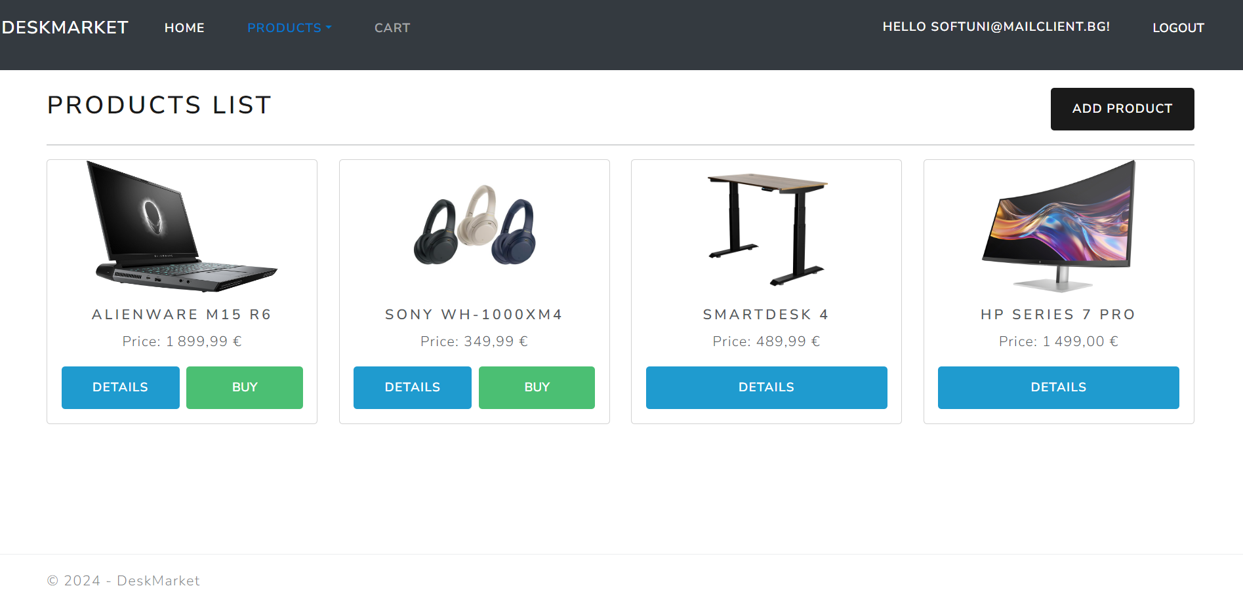
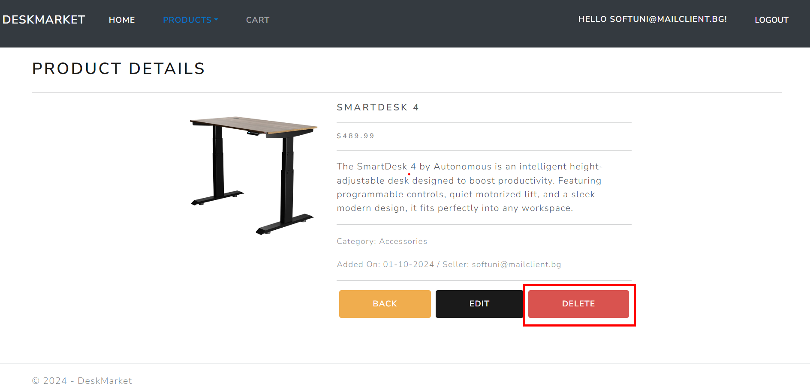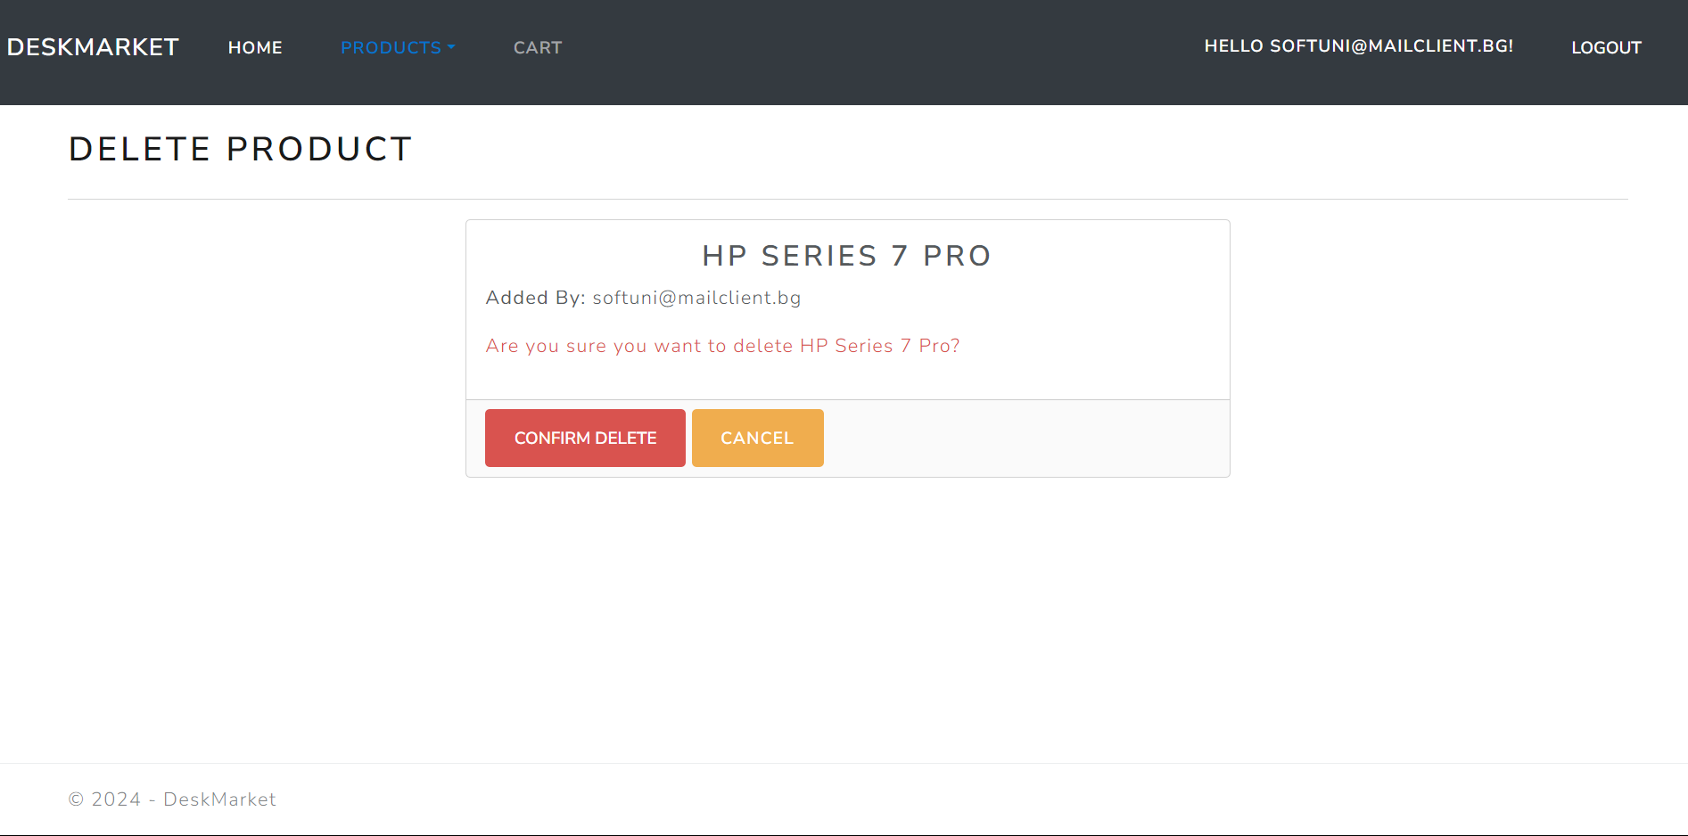
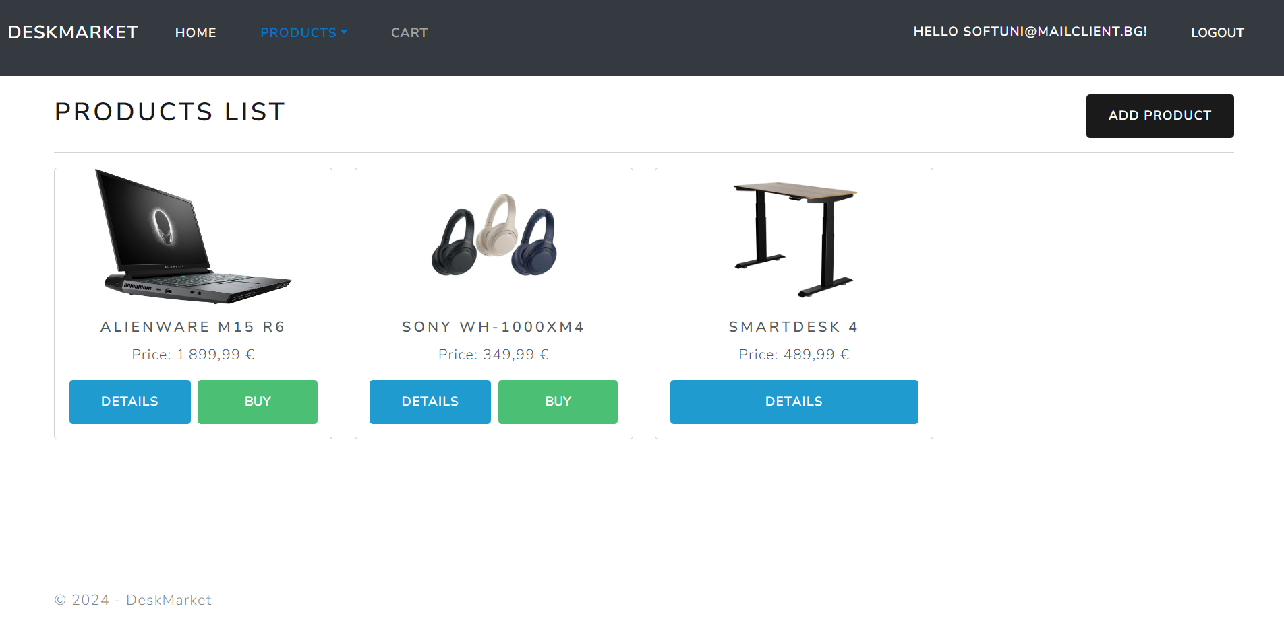
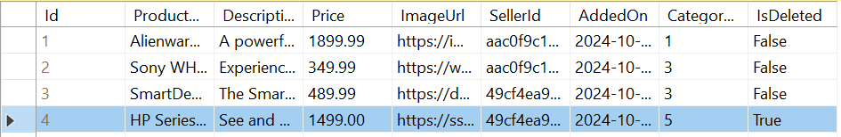

Functionality
The functionality of the DeskMarket Platform is a very simple application.

Users
Guests can Register, Login and view the HomePage and Index Page.
Users can publish products and edit products only they have added.
Users can see added products by all users on the Home Page (/Product/Index).
If the user is the seller of the product, they can't see the [Buy] button. If the user is not the seller of the product, they can add the product to their cart [Cart], , they can also see the [Details] button

Product
Product can be added by users. All added products are visualized on the Home Page (/Product/Index).
Products are visualized on the Home Page (/Product/Index) with some of their information.
Products are visualized on the Index Page (/Product/Index) with one or two buttons:
- If the user IS NOT the seller of the product – [Details][Buy]
- If the user IS the seller of the game – [Details]
The [Buy] button adds the product to the user's collection of products (Cart), unless it is already added.
The [Details] button displays a new page with the full information for the selected product. The actions and buttons displayed on this page will vary depending on the user's identity and role:
- Guest (Not Logged In):
The user can see the full details of the product but will not be able to buy, edit, or delete the product. No action buttons ([Buy], [Edit], [Delete]) will be shown.
- Logged-in User (Not the Seller):
The user will see the full details of the product and will have access to the [Buy] button, allowing them to add the product to their cart (if it has not already been purchased). The [Edit] and [Delete] buttons will not be displayed as they are not the seller of the product.
- Seller of the Product:
The seller will have full access to the product's details and will be able to see both the [Edit] and [Delete] buttons. However, the [Buy] button will not be displayed since the seller cannot purchase their own product.
The [Edit] button displays a new page with a form, filled in with all of the info for the selected product. Users can change this info and save it.

Users have a Cart page where only the products they have selected to buy are displayed.
- The [Remove From Cart] button removes the product from the user's collection of products.

Redirections
- Upon successful Login of an IdentityUser, you should be redirected to the /Product/Index
- Upon successful Publishing of a Product, you should be redirected to the /Product/Index
- Upon successful Adding a Product to the User's Cart, should be redirected to the /Product/Index
- Upon successful Editing of a Product, you should be redirected to the /Product/Details/{product_id}
- Upon successful Removal of a Product from the User's Cart, should be redirected to the /Product/Cart
- If a User buys a product, the [Buy] button disappears, and the user should not be able to duplicate products in the User's Cart. The application should also ensure that if a user tries to add a product they've already bought via other means (such as URL manipulation), the system will not duplicate the product in their cart or collection.
- Upon successful Logout of a User, you should be redirected to the Home Page
- If any of the validations in the POST forms don't pass, redirect to the same page (reload/refresh it)

Security
The Security section mainly describes access requirements. Configurations about which users can access specific functionalities and pages:
- Guest (not logged in) users can access the Home page, Product Index page, Product Details page.
- Guest (not logged in) users can access the Login page.
- Guest (not logged in) users can access the Register page.
- Guests (not logged in) cannot access Users-only pages.
- Users (logged in) cannot access Home pages.
- Users (logged in) can access the Product/Add page and functionality.
- Users (logged in) can access the Product/Edit page and functionality.
- Users (logged in) can access the Product/Index page.
- Users (logged in) can access the Product Cart page.
- Users (logged in) can access Logout functionality.
- Users (logged in) cannot access the Product/Edit page of a Product that have another user as a seller.

Code Quality
Make sure you provide the best architecture possible. Structure your code into different classes, follow the principles of high-quality code (SOLID). You will be scored for the Code Quality and Architecture of your project.

Scoring

Identity Requirements – 5 points

Database Requirements – 10 points

Template Requirements – 10 points

Functionality – 50 points

Security – 5 points

Code Quality – 10 points

Data Validation – 10 points

