02. The Squirrel
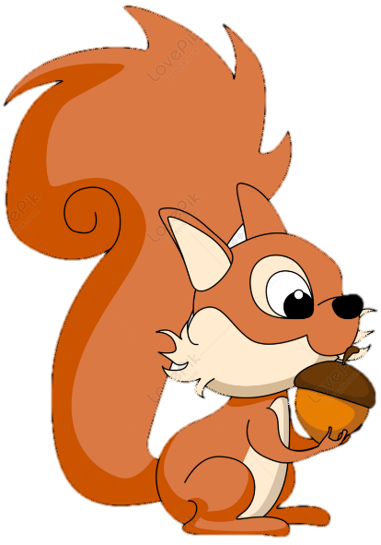
An intern from a big company must solve the game - "The squirrel". He doesn’t have enough experience, so he needs your help.
Here are the rules of the game:
The game starts with 0 collected hazelnuts. Your goal is to collect 3 of them.
You get as input the size of the field, which will be always a square shape. After that, you will receive the directions in which the squirrel can move – "left", "right", "down", and "up" in a sequence, each value separated by a comma and a space (", "). On the next rows, you will receive the field.
Possible characters in the field:
- s - represents the squirrel's position.
- h – represents a hazelnut.
- * – the asterisk represents an empty position.
- t – represents a trap.
The squirrel starts from the s - position.
- If the squirrel steps on a hazelnut, you have to increase them by 1. The position should be marked with an asterisk (*).
  - If the squirrel collects all 3 hazelnuts, the game ends and the squirrel stays in its last position.
- Asterisk (*) does nothing, so nothing happens if the squirrel steps on it.
- If it steps on a trap, the game ends and the squirrel disappears from the screen.
- If the squirrel moves out of the field, the game ends and disappears from the screen.
After all commands you will have 4 possible results:
- You win if the squirrel collects 3 of the hazelnuts.
- The squirrel collects less than 3 hazelnuts.
- The squirrel steps on a trap.
- The squirrel moves out of the field.

Input
- On the first line, you will receive the length of the field – an integer number in the range [3, 5].
- On the second line, you will receive the commands to move the squirrel – an array of strings separated by ", ".
- In the next N lines, you will receive the values for every row.

Output
- On the first line:
  - If the squirrel goes out of the field - "The squirrel is out of the field.".
  - If the squirrel steps on a trap - "Unfortunately, the squirrel stepped on a trap...".
  - If the squirrel hasn’t collected all hazelnuts - "There are more hazelnuts to collect.".
  - If the squirrel has collected all hazelnuts - "Good job! You have collected all hazelnuts!".
- On the second line, print the number of collected hazelnuts - "Hazelnuts collected: {hazelnutsCount}"

Constraints
- The size of the field will be between [3,5].
- There could be one or no trap on the field.
- There will always be 3 hazelnuts on the field.

Examples
Input | Output | Comments
5  left, left, up, right, up, up  **h**  t****  *h***  *h*s*  ***** | Good job! You have collected all hazelnuts!  Hazelnuts collected: 3 | The squirrel moves 2 times to the left and collects its first hazelnut. After that collect the second one. Finally, with the last "up" command, the squirrel collects its final hazelnut.
4  down, down, right, right  *s*h  ***h  ***t  h*** | Unfortunately, the squirrel stepped on a trap...  Hazelnuts collected: 0
4  down, down, right, right  h***  ***h  *s*t  **h* | The squirrel is out of the field.  Hazelnuts collected: 0

