More Exercises: HTML and CSS Overview, HTML Structure
Problems for exercises and homework for the "HTML and CSS" course @ SoftUni. Submit your solutions in the SoftUni judge system at https://judge.softuni.bg/Contests/396/HTML-and-CSS-More-Exercises.

Create Header
Create a Web Page like the screenshot below:

Create two files: "create-header.html" and "create-header.css"
Use semantic HTML to create the HTML page.

Constraints
- <body>
  - Font-family: "Lato", sans-serif;
  - Text color: #ffffff;
- <header> with class="container"
  - Center the container
  - Padding: 0 10px;
  - Background: url(background-image.jpg) no-repeat center center;
  - Background size: cover;
  - Height: 800px;
  - Text center
- <h1> for heading
  - Text size: 80px;
  - Padding: 80px 0;
  - Letter spacing: 8px;
  - Transform the heading text to uppercase with CSS (see http://www.w3schools.com/cssref/pr_text_text-transform.asp).
- Paragraph for the text
  - Text size: 27px;
  - Font weigth: 100;
  - Margin: 20px;
  - Escape the quotes using &quot;
- <button> with class btn for button
  - Text color: #ffffff;
  - Background: none;
  - Border: 5px solid #ffffff;
  - Border radius: 15px;
  - Margin top: 40px;
  - Padding: 15px 45px;
  - Text size: 16px;
- Button on hover
  - Background: #000;
  - Border color: #000;
  - Cursor: pointer;

Hints
Reset the CSS margins and paddings, like it is explained here: https://css-tricks.com/reset-all-margins-padding/.

Create Content
Create a Web Page like the following.
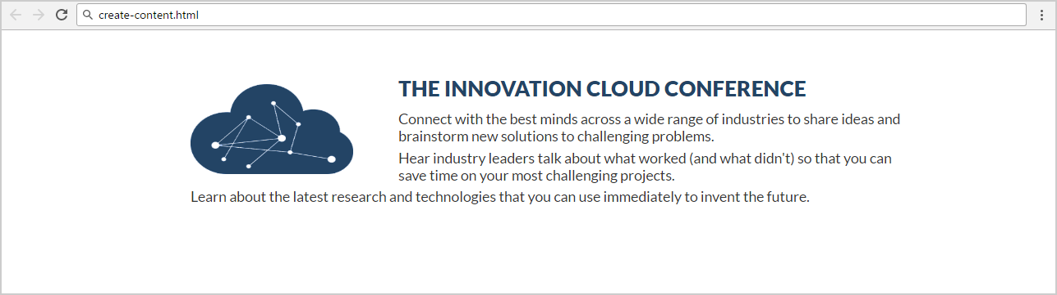
Create two files: "create-content.html" and "create-content.css"

Constraints
- Font-family: "Lato", sans-serif;
- <main> as a container
  - Margin: 50px 200px;
  - Max width: 1060px;
  - Padding: 0 10px;
- <h2> for heading
  - Text color: #234465;
  - Margin: 10px;
- Paragraph
  - Text size: 16px;
  - Text color: #333333;
  - Margin bottom: 5px;
  - Letter spacing: 0;
  - Width: 800px;
- Image
  - Align the image on the left side.
  - Width: 180px;
  - Height: 100px;
  - Margin: 10px 50px 0 0;

Book Story
- Create a Web Page like the following using Book-Story.txt.
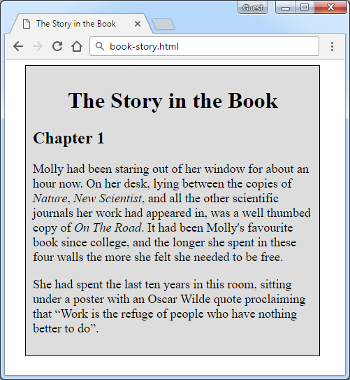
Create two files: “book-story.html” and “book-story.css”

Constraints
- <div> with id=wrapper as a container
  - Width container: 400px
  - Background color: #dddddd
  - Border: 1px solid #000000
  - Margin Left: 20px
  - Padding: 10px
- <p> tag for paragraph + font-size: 18px
- <em> tag for italic text

Hints
Use:
- <h1> tag for heading + center the text
- <q> tag for quotation text

  - q::before {
content: open-quote;
}
  - q::after {
content: close-quote;
}

Innovation Cloud
Create a Web Page like the following.
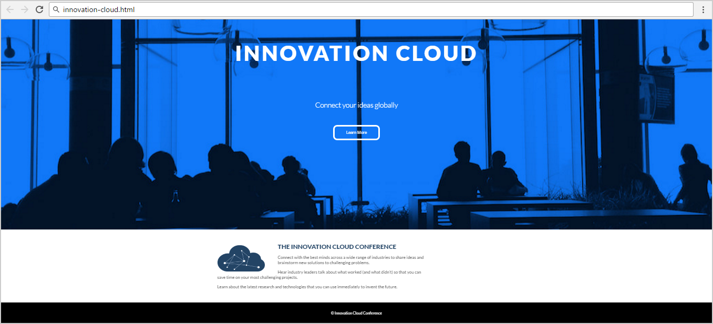
Create two files: "innovation-cloud.html" and "innovation-cloud.css"
Use Semantic HTML to create the page

Constraints
- Problem 3 + Problem 4
- Footer
  - Background color: #000000;
- Text in the footer
  - Text color: #ffffff;
  - Text size: 14px;
  - Height: 80px;
  - Line height: 80px;
  - Margin: 0px;
  - Use the HTML entity for the “Copyright” character “©”.

Conference
Create a Web Page like the following.
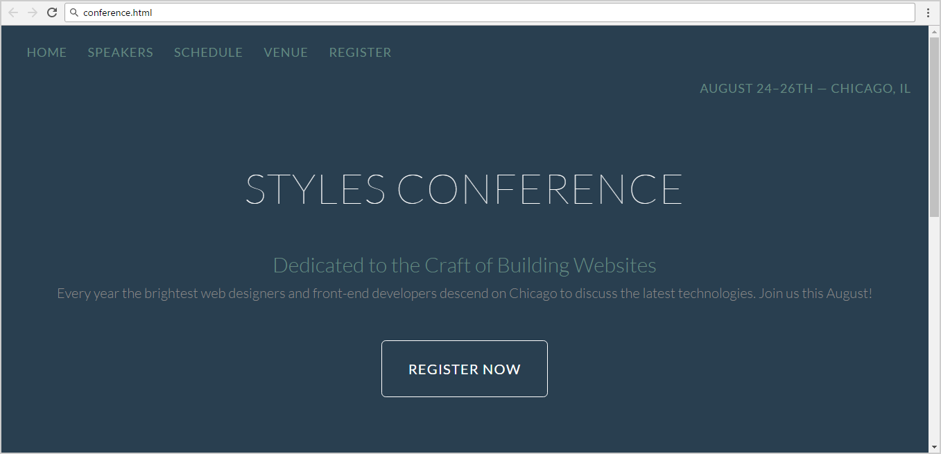
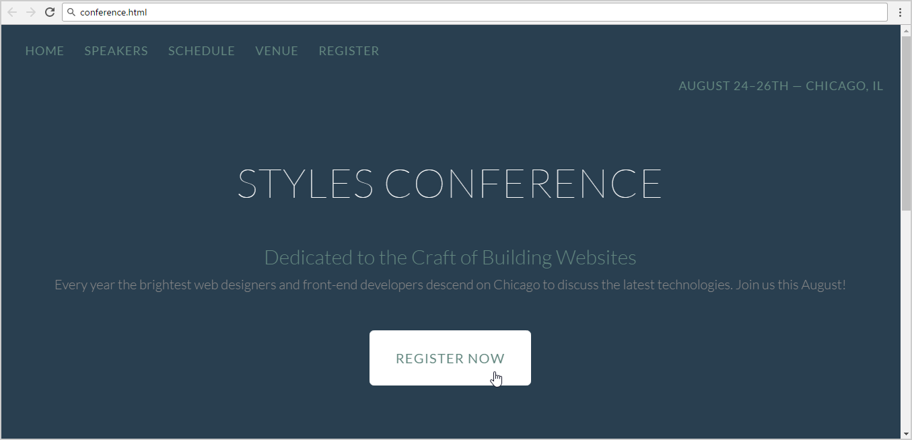
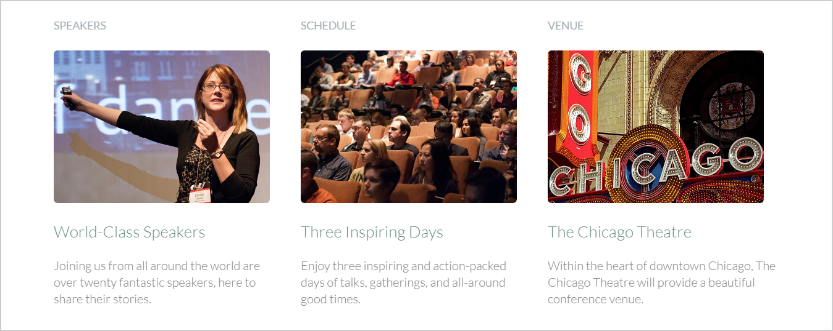

Create two files: "conference.html" and "conference.css"
Use semantic HTML to create the HTML page.

Hints
- You may use color picker software (search in Google) to select the color of certain screen pixel.
- Use a hyperlink for the button.
- Get the “Lato” font from: http://fonts.googleapis.com/css?family=Lato:100,300,400.
- Default font: 300 16px/22px "Lato", sans-serif

World Cup News
Create a Web Page like the following using World-Cup-News.txt.
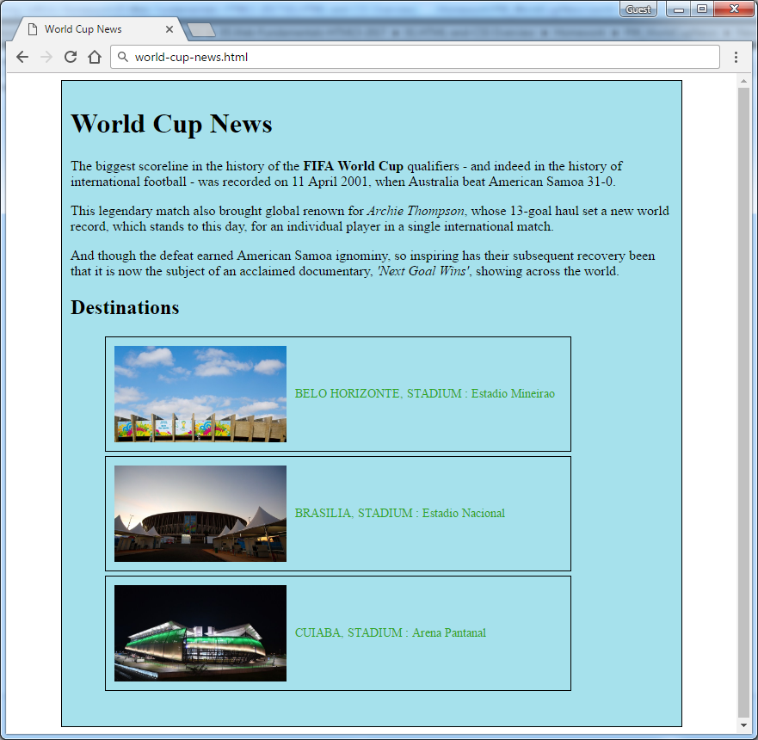
Create two files: “world-cup-news.html” and “world-cup-news.css”

Constraints
- <div> with id= "wrapper" as a container
  - Width container: 700px
  - Height container: 730px
  - Border: 1px solid #000000
  - Center the container
  - Padding: 10px
  - Background color: #a6e1ec
- <h1> and <h2> tags for headings
- <p> tag for paragraph
- <strong> tag for bold text
- <em> tag for italic text
- <img> tag for images
  - Width: 200px
  - Margin Right: 10px
  - Vertical Align: middle
- <span class= "text"> for the text next to images
  - Text color: #2EA620
- <li> tag
  - Width: 520px
  - Padding: 10px
  - Margin Bottom: 5px
  - Font Size: 14px
  - Border: 1px solid #000000

Book Store
Create a Web Page like the following.
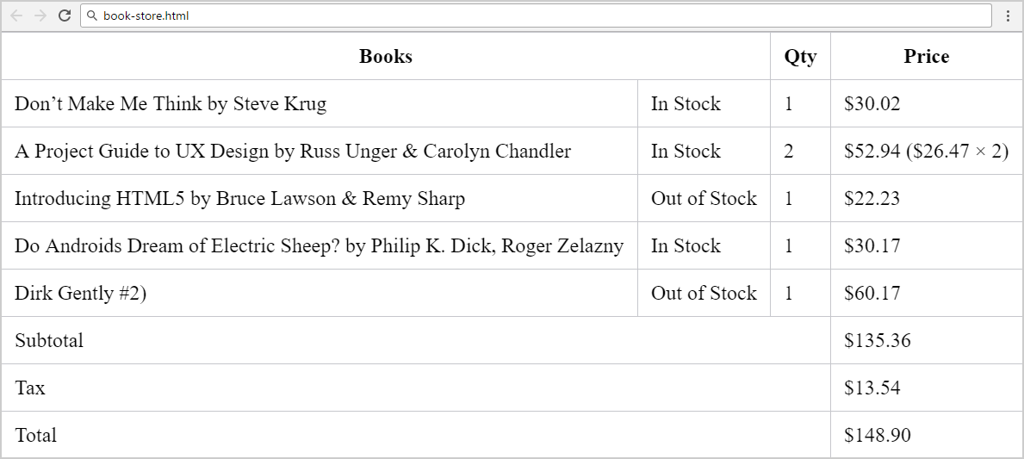
Create two files: "book-store.html" and "book-store.css".

Constraints
- Merge columns in several table rows by using “colspan”.
- Table border color: #c6c7cc.
- Apply padding for all table cells.
- Collapse table borders to remove the empty space between the cells: https://css-tricks.com/almanac/properties/b/border-collapse/.

Hints
Use:
- First reset the CSS styles.
- Use &#8217; for the apostrophe.
- Search Internet for currency symbol HTML entiities and other special symbols like &.

